Getting Started with Strands Agents

What is Strands Agents?
Strands Agents is an open source SDK that takes a model-driven approach to building and running AI agents in just a few lines of code. It provides developers with a streamlined framework to create intelligent agents that can perform a wide range of tasks, from simple interactions to complex multi-agent collaborations.
The SDK simplifies the complexity of agent development, allowing you to focus on defining agent behavior and capabilities rather than worrying about the underlying implementation details. With Strands Agents, you can quickly prototype AI agents that leverage the power of large language models (LLMs) like Amazon Nova Anthropic Claude , and others. Like the two strands of DNA, Strands connects two core pieces of the agent together: the model and the tools.

Features and Benefits
Simplified Agent Development
Strands Agents accelerates development time by enabling you to create fully functional AI agents with minimal code. Through its intuitive interface, you can define agent behavior using system prompts and tool configurations, allowing for rapid prototyping and iteration. This simplified approach means you can focus on business logic rather than agent infrastructure.
Core concepts of Strands Agents
The simplest definition of an agent is a combination of three things:
- a model
- tools
- a prompt
The agent uses these three components to complete a task. The agent’s task could be to answer a question, generate code, plan a vacation, or optimize your financial portfolio. In a model-driven approach, the agent uses the model to dynamically direct its own steps and to use tools in order to accomplish the specified task.
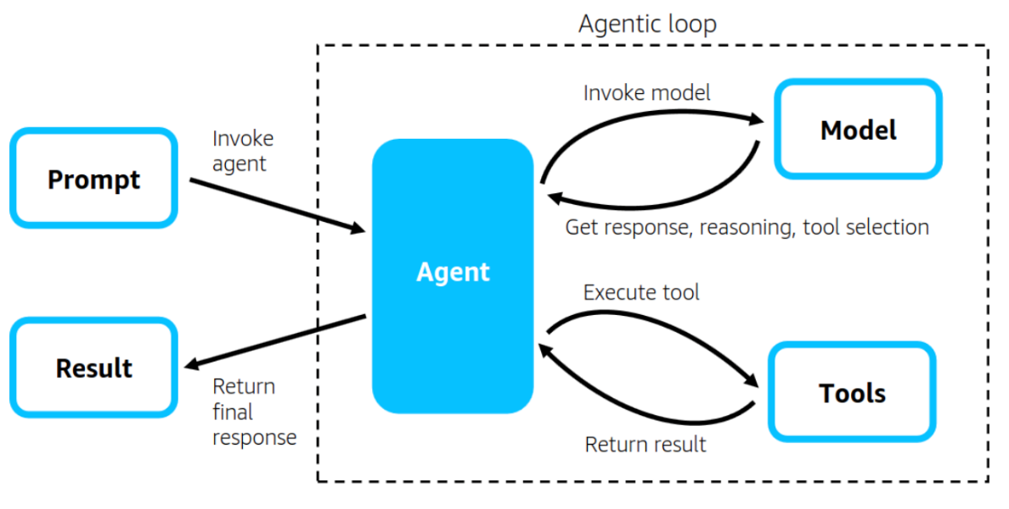
An agent interacts with its model and tools in a loop until it completes the task provided by the prompt. This agentic loop is at the core of Strands’ capabilities. The Strands agentic loop takes full advantage of how powerful LLMs have become and how well they can natively reason, plan, and select tools. When the LLM selects a tool, Strands takes care of executing the tool and providing the result back to the LLM. When the LLM completes its task, Strands returns the agent’s final result.

Flexible Tool Integration
The SDK offers flexibility in tool integration, supporting both built-in and custom tools. Built-in tools handle common tasks like calculations and making API requests, and interacting with AWS APIs, while the custom tool framework lets you extend agent capabilities with specialized functions. You can easily use any Python function as a tool, by simply using the Strands @tool decorator. Additionally, Model Context Protocol (MCP) integration connects your agents to external services and resources, expanding their capabilities without complex coding. This extensibility ensures your agents can adapt to evolving requirements and integrate with existing systems.

Multi-Model Support
Multi-model support is a cornerstone of Strands Agents, giving you the freedom to choose the right foundation for your specific use case. You can use any model in Amazon Bedrock like Claude 3.7, a model from Anthropic through the Anthropic API, a model from the Llama model family via Llama API, Ollama for local development, and other model providers such as OpenAI through LiteLLM. You can additionally define your own custom model provider with Strands. You can easily switch between different LLM providers and configure model parameters to optimize performance, ensuring your agents leverage the most appropriate AI technology for each task.

Advanced Multi-Agent Architectures
Multi-agent collaboration is a key functionality for agent development. Out-of-the box Strands Agents supports four types of multi-agent collaboration: Agent as Tool , Swarm , Graph and Workflow . The Agent-as-Tool pattern enables hierarchical structures where specialized agents serve as tools for orchestrator agents, mimicking human team dynamics. Swarm Agents allows you to build multiple agents working in parallel with different collaboration patterns (collaborative, competitive, or hybrid), while Graph Agents allow you to build structured networks of specialized agents with explicit communication patterns. Workflow Agents provide task orchestration capabilities for complex processes with distinct sequential stages, supporting both sequential and parallel execution paths with priority-based scheduling, comprehensive monitoring, and auto-recovery features. These architectures enable sophisticated problem-solving approaches that distribute tasks among specialized components.
Enterprise-Ready Capabilities
The Strands Agents project includes deployment examples with a set of reference implementations for AWS Lambda, Fargate, and EC2. The SDK supports streaming responses for real-time interactions. Strands uses OpenTelemetry (OTEL) to emit telemetry data to any OTEL-compatible backend for visualization, troubleshooting, and evaluation. Strands’ support for distributed tracing enables you to track requests through different components in your architecture, in order to paint a complete picture of agent sessions. Amazon Bedrock models provide built-in support for guardrails and content filtering capabilities that can be leveraged when using these models with Strands Agents.
Throughout this workshop, we'll explore Strands Agents' capabilities and build practical examples that demonstrate how this SDK can transform your approach to building AI applications.
The workshop follows the official AWS Strands Agents GitHub repository.

Prerequisites
Overview
This workshop assumes that you have a good understanding of generative AI area and are familiar with solutions like Retrieval Augmented Generation (RAG) , AWS services like Amazon Bedrock , Amazon Fargate , Amazon Dynamo DB and hands on experience with Python is recommended.
You have two options to run this workshop:
- At an AWS event
- Self-paced in your own AWS environment
The workshop contains a number of examples of how to work with Strands Agents SDK.
Notebooks that you will run to execute the workshop will be provided for you, we will use Amazon Sagemaker Studio for easier packaging the development environment (AWS event) when using Strands Agents you can use any IDE of your choice (self-paced).

Sagemaker AI Studio

Start SageMaker AI Studio

After signing into the AWS account, follow Launch Amazon SageMaker Studio instructions to open Studio.
Here are the instructions if you are in an AWS-led workshop event:
- Federate into Amazon SageMaker console from the Open AWS console link in the workshop left panel:
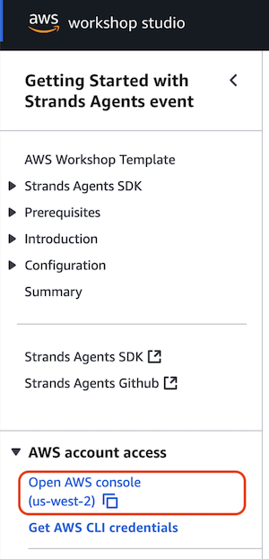.
- In AWS console navigate to Amazon SageMaker AI console, you can do this by simply starting to type SageMaker AI in the search box at the top.
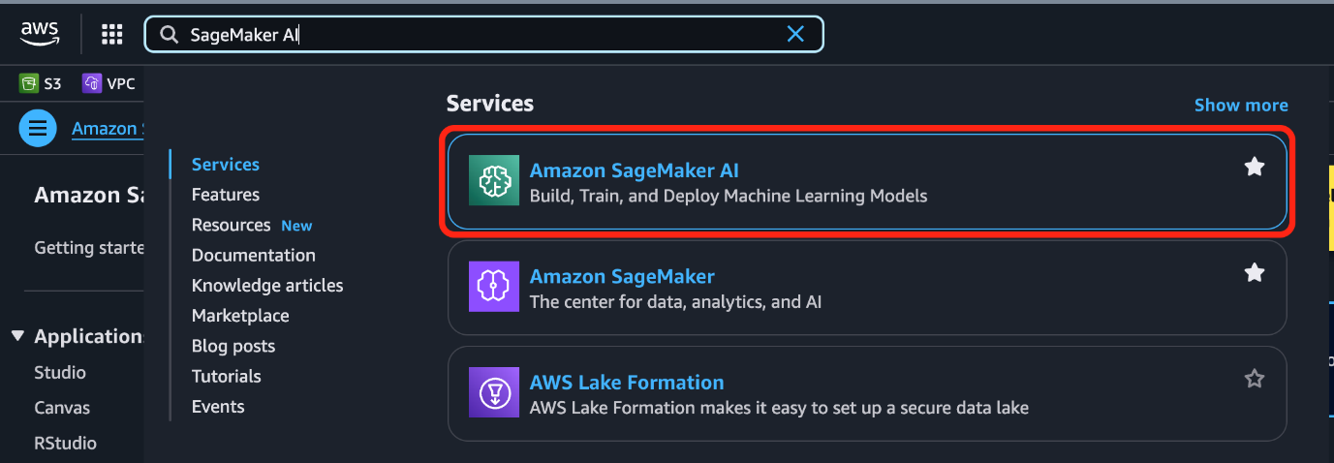.
- On the left in the Applications and IDEs section select Studio
- In the Get started box, make sure the strandsuser is selected and select Open studio. Now SageMaker Studio UI opens in a new browser tab and you're redirected to that window.
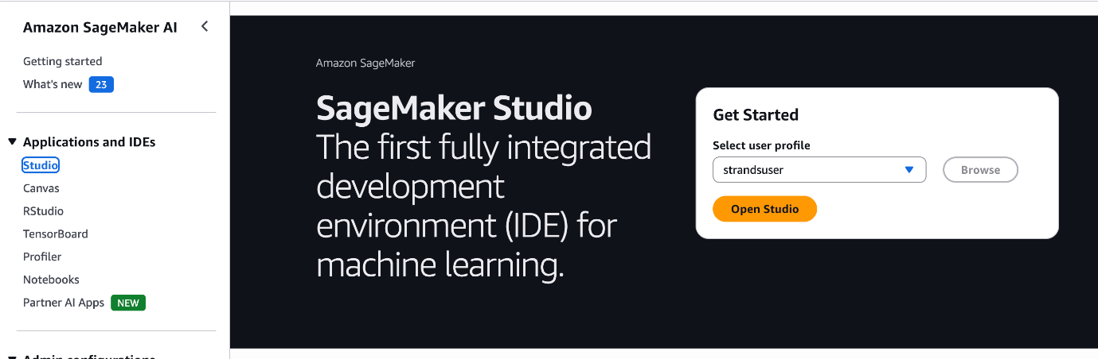.
Optionally take the quick tour of the SageMaker Studio interface by selecting the Take quick tour button or select Skip Tour for now
Accept or Decline the cookie preferences based on your preference

Open JupyterLab space

You use a JupyterLab space as our IDE for this workshop.
- To launch a JupyterLab space, select the JupyterLab app in the top left
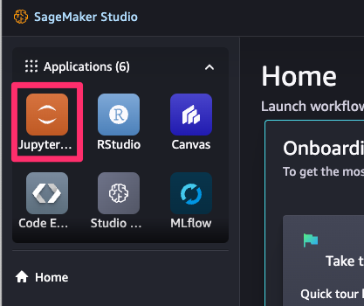
- Each application in Studio gets its own space. Spaces are used to manage the storage and resource needs of each application. If you're participating in an AWS-led workshop or used the provided CloudFormation template, the required space is already created for you, otherwise create a new JupyterLab space with defaults using the Developer Guide
- Run the space by selecting the run button on the right. This process can take a few seconds.
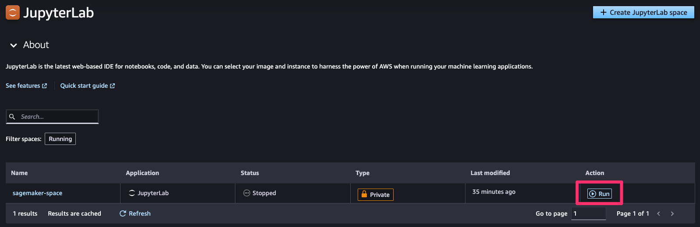
- Once the space is running select Open to navigate to the JupyterLab application.

Start the workshop

The public GitHub repository with Strands Agents samples contains all source code.
If you're participating in an AWS-led workshop, the workshop content is cloned into the space volume automatically, no action required from you. If you use your own domain and user profile, you need to clone the repository first. To do this select Terminal in the Launcher window or select File > New > Terminal to open up a terminal and run the git clone:
1 git clone https://github.com/strands-agents/samples.git
This will clone the repository into the local JupyterLab file system.
Your're all set ! Proceed to Fundamentals with Strands Agents Section.

Fundamentals

Fundamentals of building an AI agent with Strands agents

This section contains a series of tutorials covering the fundamental concepts of building AI agents with AWS Strands. Each tutorial builds upon the previous one, introducing key concepts and features to help you create sophisticated AI agents.
You will explore the following tutorials:
- Lab 1 : Quick Start to creating a Strands Agent
- Lab 2 : Model Providers
- Lab 3 : Connecting with AWS services
- Lab 4 : Model Context Protocol with Strands Agent
- Lab 5 : Guardrails and Responsible AI
- Lab 6 : Advanced processing of agents' responses
- Lab 7 : Memory Persistent Agents
- Lab 8 : Agent Observability and Evaluation
Lets get started !!!

Lab 1 - Getting Started

Quickstart Guide for Strands Agents

Strands Agents is a SDK for building AI agents that can interact with AWS services and perform complex tasks. This quickstart guide will help you get started with creating your first Strands agent.

Prerequisites

Before you get started, please check the following prerequisites. Specific lab may have other pre-requisistes listed in the lab.
- Python 3.10 or later
- AWS account configured with appropriate permissions
- Basic understanding of Python programming is not a requirement, but recommended.
Lets get started !

Installation

Proceed to the workbook samples/01-tutorials/01-fundamentals//01-first-agent/01-first-agent.ipynb in which you will initiate the below steps.
Install Strands using pip:
pip install strands-agents strands-agents-tools

Creating Your First Agent
1. Create a simple Agent:
from strands import Agent
# Initialize your agent
agent = Agent(
system_prompt="You are a helpful assistant that provides concise responses."
)
# Send a message to the agent
response = agent("Hello! What can you do?")
print(response)

2. Add Tools to the Agent:
The strands-agents-tools repository provides some pre-implemented tools which you can import. Additionally, a simple way to add custom tools is using the @tool decorator. Explore the in-built tools if you would like to use them directly with your agent for example a calculator. In cases in which you want to create custom logic for the Agent, use the @tool decorator.
Here is an example of both approaches:
from strands import Agent, tool
from strands_tools import calculator
@tool
def weather():
""" Get weather """ # Dummy implementation
return "sunny"
agent = Agent(
tools=[calculator, weather],
system_prompt="You're a helpful assistant. You can do simple math calculation, and tell the weather.")
response = agent("What is the weather today?")
print(response)

For some applications it is important to directly call the tool. For instance, you might want to debug the tool, pre-populate the agent knowledge with your customer's information or using a tool inside of another tool. In Strands you can do it using the tool method of your agent followed by the tool name.You can invoke the tool directly like so:
# Calculate derivative
agent.tool.calculator(expression="sin(x)", mode="derive", wrt="x", order=2)

3. Changing the log level and format:
Strands SDK uses Python's standard logging module to provide visibility into its operations. To enable debug logs in our agent, configure the strands logger . It uses standard Python log levels, with specific usage patterns such as DEBUG, WARNING, ERROR. If you want to change the log level, for example during debugging, or modify the log format, you can set the logger configuration as follows:

import logging
from strands import Agent

# Enables Strands debug log level
logging.getLogger("strands").setLevel(logging.DEBUG) # or logging.ERROR

# Sets the logging format and streams logs to stderr
logging.basicConfig(
format="%(levelname)s | %(name)s | %(message)s",
handlers=[logging.StreamHandler()]
)

agent = Agent()
agent("Hello!")

4. Model Provider

Strands Agents supports several model providers beyond Amazon Bedrock:
- Anthropic - Direct API access to Claude models
- LiteLLM - Unified interface for OpenAI, Mistral, and other providers
- Llama API - Access to Meta's Llama models
- Ollama - Run models locally for privacy or offline use
- OpenAI - Direct API access to OpenAI or OpenAI-compatible models
- Custom Providers - Build your own provider for specialized needs
The default model provider is Amazon Bedrock and the default model is Claude 4 Sonnet in the region of your AWS configuration.
You can specify a different model in Amazon Bedrock providing the model ID string directly :
from strands import Agent

agent = Agent(model="us.anthropic.claude-haiku-4-5-20251001-v1:0")
print(agent.model.config)
For more control over the model configuration, you can create a BedrockModel provider instance:
import boto3
from strands import Agent
from strands.models import BedrockModel
# Create a BedrockModel
bedrock_model = BedrockModel(
model_id="us.anthropic.claude-haiku-4-5-20251001-v1:0",
region_name='us-west-2',
temperature=0.3,
)
agent = Agent(model=bedrock_model)
More details on the available model providers on the Model Provider Quickstart page

Example: Task-Specific Agent

Here's a practical example of a task-specific agent. Here we create a RecipeBot that recommends recipes and answers any cooking related questions.
First we install the duckduckgo-search package for a free and opensource web-search API.
1
pip install duckduckgo-search
Now lets build this agent:
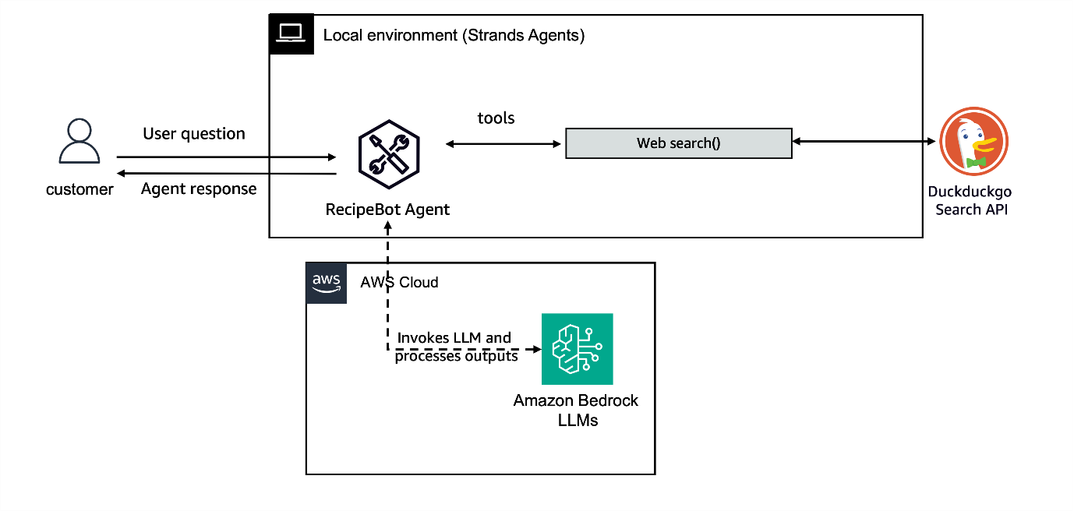

from strands import Agent, tool
from duckduckgo_search import DDGS
from duckduckgo_search.exceptions import RatelimitException, DuckDuckGoSearchException
import logging

# Configure logging
logging.getLogger("strands").setLevel(logging.INFO)

# Define a websearch tool
@tool
def websearch(keywords: str, region: str = "us-en", max_results: int | None = None) -> str:
"""Search the web to get updated information.
Args:
keywords (str): The search query keywords.
region (str): The search region: wt-wt, us-en, uk-en, ru-ru, etc..
max_results (int | None): The maximum number of results to return.
Returns:
List of dictionaries with search results.
"""
try:
results = DDGS().text(keywords, region=region, max_results=max_results)
return results if results else "No results found."
except RatelimitException:
return "RatelimitException: Please try again after a short delay."
except DuckDuckGoSearchException as d:
return f"DuckDuckGoSearchException: {d}"
except Exception as e:
return f"Exception: {e}"

# Create a recipe assistant agent
recipe_agent = Agent(
system_prompt="""You are RecipeBot, a helpful cooking assistant.
Help users find recipes based on ingredients and answer cooking questions.
Use the websearch tool to find recipes when users mention ingredients or to look up cooking information.""",
tools=[websearch], # Import the websearch tool we created above
)

response = recipe_agent("Suggest a recipe with chicken and broccoli.")

print(f"Metrics : {response.metrics}") # Optional, but recommended.
And that's it! We now have a running usecase with tools in just a few lines of code 🥳.
For more detailed quickstart guide, check out the Strands documentation .
This quickstart guide covers the basics of getting started with Strands agents. For more advanced features and detailed documentation, refer to the specific sections in the documentation.
Try it out
At an AWS Event
If you are following the workshop via workshop studio, now go to JupyterLab in SageMaker Studio. In the JupyterLab UI navigate to 01-tutorials/01-fundamentals/01-first-agent/01-first-agent.ipynb

Self-paced
Here's a notebook that lets you try out the above: Getting started with Strands and building your first usecase .

Lab 2 - Model providers

Model Providers in Strands Agents

Strands Agents supports multiple model providers, allowing you to choose the best foundation model for your specific use case. This flexibility enables you to build agents that can leverage different capabilities, cost structures, and deployment options.

Supported Model Providers

Strands Agents supports several model providers out of the box:
- AWS Bedrock : Use Amazon's managed service to access high-performing foundation models from leading Providers like Anthropic, Meta, Amazon etc.
- Anthropic : Direct API access to Claude models
- Ollama : Run models locally for privacy or offline use
- LiteLLM : Unified interface for OpenAI, Mistral, Gemini and other providers
  - Azure OpenAI: Leverage OpenAI models hosted on Microsoft Azure
  - OpenAI: Access models like GPT-4/ gpt-4o
- Custom Providers : Build your own provider for specialized needs
For all models you can add Callback Handlers that allow you to intercept and process events during agent execution.

Basic Model Configuration

To use a model with Strands Agents, you need to:
- Import the appropriate model class
- Configure the model with required parameters
- Pass the model to your agent

Model Selection Considerations

When choosing a model provider, consider:
- Accuracy and Latency: Different models excel at different tasks
- Cost: Pricing varies significantly between providers
- Privacy: Some use cases may require local deployment, guardrails. Models in Bedrock allow for seamless integration with Bedrock Guardrails.
- Context length: Maximum input size varies by model

Lab Exercises

In this lab, you'll explore different model providers:
- Ollama Model - Run models locally
- OpenAI Model - Use cloud-based models (Optional Lab)
Each exercise will guide you through setting up and using a specific model provider with Strands Agents.
Lets get started !

OpenAI Models via LiteLLM (Optional)

Using OpenAI with Strands Agents

LiteLLM is a unified interface for various LLM providers that allows you to interact with models from Amazon, Anthropic, OpenAI, Gemini and many others through a single API. The Strands Agents SDK implements a LiteLLM provider, allowing you to run agents against any model LiteLLM supports. You can read about LiteLLM supported Model providers here .
For the scope of this lab, let's look at OpenAI provided LLM that can be integrated with Strands Agents to create sophisticated AI applications.
⚠️ Warning
This lab requires OpenAI keys and is NOT mandatory
Here's what we will build in this Lab:
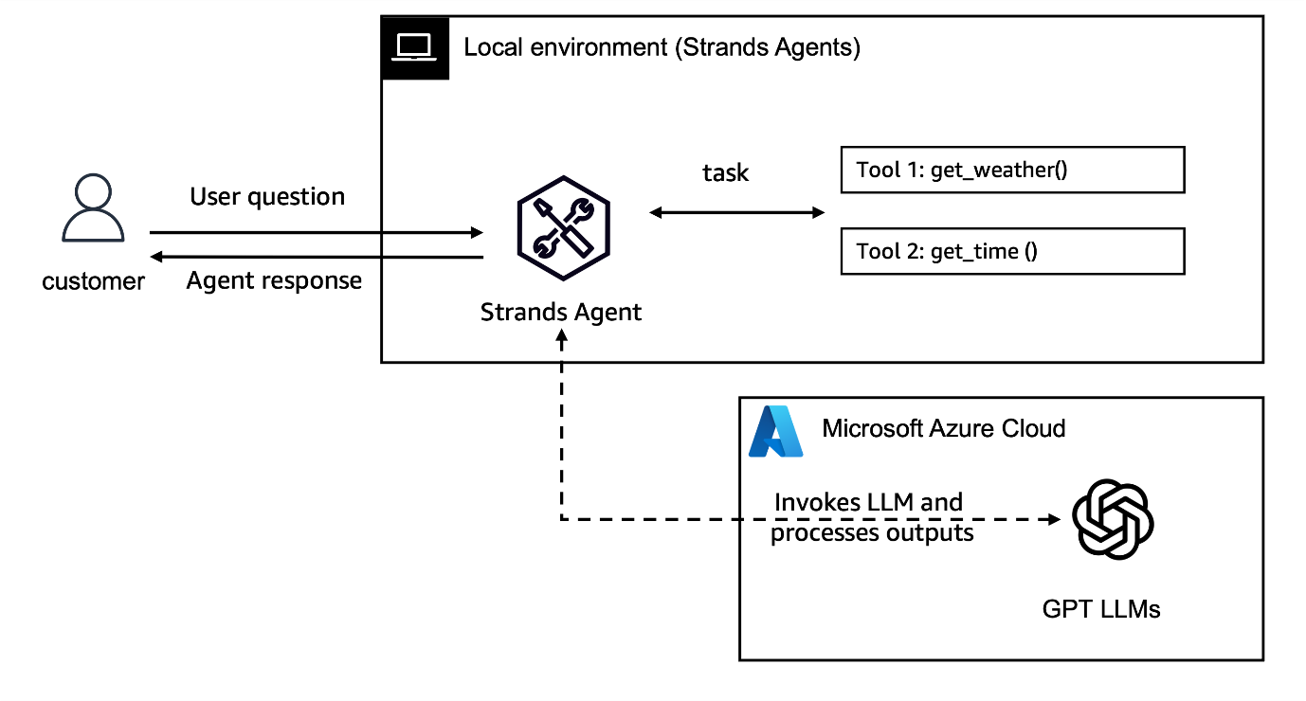

Prerequisites

For this Lab, you need access to Azure OpenAI service and the 3 API key values:
1
2
3
os.environ["AZURE_API_KEY"] = "<YOUR_API_KEY>"
os.environ["AZURE_API_BASE"] = "<YOUR_API_BASE>"
os.environ["AZURE_API_VERSION"] = "<YOUR_API_VERSION>"
Important
When using OpenAI models, please know that you would be responsible for API usage costs based on LLM token consumption.

Setting Up the OpenAI Model via LiteLLM

To setup, and initialize the OpenAI model using LiteLLM, you need to add the model_id in the specified format: <model_provider>/<model_name>.
1
2
3
4
5
6
7
8
9
10
11
12
from strands.models.litellm import LiteLLMModel

# For Azure OpenAI API
openai_model = LiteLLMModel(
model_id="azure/gpt-4.1-mini", # Choose the required model
params={
"max_tokens": 4096, # Adjust based on your model's capabilities
"temperature": 0.7, # Lower for more deterministic responses, higher for more creative
"top_p": 0.9, # Nucleus sampling parameter
"stream": True, # Enable streaming responses
},
)

Creating an Agent with OpenAI

After setting up the model, you can create an agent:
1
2
3
4
5
6
7
8
9
10
11
12
13
from strands_tools import current_time

@tool
def current_weather(city: str) -> str:
"""Get the current weather for a city (dummy implementation)."""
return "Sunny"

# Create the agent with tools
assistant = Agent(
system_prompt="You are a helpful assistant. You only answer questions about time and weather", # Define a system Prompt
model=openai_model, # Use the OpenAI model we configured above
tools=[current_time, current_weather],
)
Using the Agent
Once your agent is set up, you can interact with it:
# Ask the agent a question that requires using tools
result = assistant("What time is it in Seattle? And how is the weather?")
# You can examine the conversation history
print(assistant.messages)
# You can also check usage metrics
print(result.metrics)
You'll see that the agent will automatically:
- Call the current_time tool with "America/Los_Angeles" timezone
- Call the current_weather tool with "Seattle" as the city
- Format a helpful response with the results
Feel free to tune the system_prompt if it doesn't.
Next Steps
To experiment and learn further, you can:
- Implement more complex tools like web search, data analysis, or document processing
- Create a multi-agent system where agents with different specialties collaborate

Try it out
At an AWS Event

If you are following the workshop via workshop studio, now go to JupyterLab in SageMaker Studio. In the JupyterLab UI navigate to 01-tutorials/01-fundamentals/02-model-providers/02-openai-model/openai-litellm-agent.ipynb

Self-paced

Here's a notebook that lets you try out the above: Create Agent with OpenAI Model .

Lab 3 - Connecting with AWS Services

Connecting with AWS Services

In this example we will guide you through how to create your first Strands Agent. Agents in order to be effective need to connect to multiple different tools and services, including services provided by AWS. In this module you will find a complete step by step example on how to build a restaurant booking assistant using Strands Agents SDK which will be driven by Amazon Bedrock provided LLM, use Amazon Bedrock Knowledge Bases and DynamoDB to hold the records of the restaurant bookings.

Running Strands Agents

By default agents are running on environment they are being created. That means if they are being created on local machine - they are running from your local machine. If you are running this workshop notebooks on AWS Sagemaker Studio - they will be run from the studio instance that runs the notebook. You can also deploy agents to run in the cloud - for those case please refer to the deployment section of this workshop to see how you can deploy agents running as AWS Lambda function or via AWS Fargate

Agent Architecture

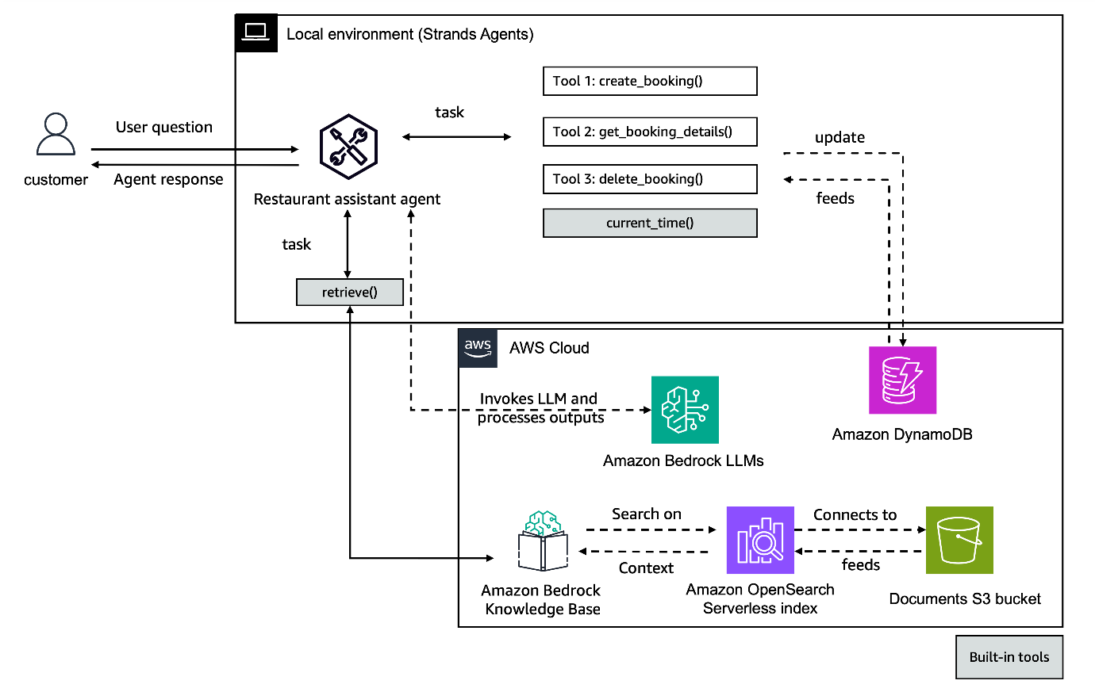

Prerequisites

- Python 3.10+
- AWS account
- Anthropic Claude Sonnet 4.5 enabled on Amazon Bedrock
- IAM role with permissions to create Amazon Bedrock Knowledge Base, Amazon S3 bucket and Amazon DynamoDB
Run shell script to deploy needed infrastructure elements. Copy the deploy_prereqs.sh file from here :
!sh deploy_prereqs.sh

Setup agent configuration

Next we will set our agent configuration. We will read the Amazon Bedrock Knowledge Base id and Amazon DynamoDB table name from the parameter store.
1
2
3
4
5
6
7
8
9
10
kb_name = "restaurant-assistant"
dynamodb = boto3.resource("dynamodb")
smm_client = boto3.client("ssm")
table_name = smm_client.get_parameter(
Name=f"{kb_name}-table-name", WithDecryption=False
)
table = dynamodb.Table(table_name["Parameter"]["Value"])
kb_id = smm_client.get_parameter(Name=f"{kb_name}-kb-id", WithDecryption=False)
print("DynamoDB table:", table_name["Parameter"]["Value"])
print("Knowledge Base Id:", kb_id["Parameter"]["Value"])

Defining custom tools

In order to correctly connect and work with Amazon DynamoDB we need to create tools that will be relevant to every action agent would ned to take when working on restaurant reservations:
- get_booking_details: Get the relevant details for booking_id in restaurant_name
- create_booking: Create a new booking at restaurant_name
- delete_booking: Delete an existing booking_id at restaurant_name

Tool definition approach

There are 3 ways in which you can define tools to be used with the agent when using this SDK.
- standalone file - create separate file with tool defining code and import to an agent code
- decorator approach - similar to above but reference function by @tool decorator within the code
- TOOL_SPEC approach - define your tool function using TOOL_SPEC dictionary
See below example for the decorator approach example for one of the 3 tool used in this lab - delete_booking tool:
%%writefile delete_booking.py
from strands import tool
import boto3

@tool
def delete_booking(booking_id: str, restaurant_name:str) -> str:
"""delete an existing booking_id at restaurant_name
Args:
booking_id: the id of the reservation
restaurant_name: name of the restaurant handling the reservation

Returns:
confirmation_message: confirmation message
"""
kb_name = 'restaurant-assistant'
dynamodb = boto3.resource('dynamodb')
smm_client = boto3.client('ssm')
table_name = smm_client.get_parameter(
Name=f'{kb_name}-table-name',
WithDecryption=False
)
table = dynamodb.Table(table_name["Parameter"]["Value"])
try:
response = table.delete_item(Key={'booking_id': booking_id, 'restaurant_name': restaurant_name})
if response['ResponseMetadata']['HTTPStatusCode'] == 200:
return f'Booking with ID {booking_id} deleted successfully'
else:
return f'Failed to delete booking with ID {booking_id}'
except Exception as e:
return str(e)
See below example of creating a tool definition for create_booking tool using TOOL_SPEC approach:
1
2
3
4
5
6
7
8
9
10
11
12
13
14
15
16
17
18
19
20
21
22
23
24
25
26
27
28
29
30
31
32
33
34
35
36
37
38
39
40
41
42
43
44
45
46
47
48
49
50
51
52
53
54
55
56
57
58
59
60
61
62
63
64
65
66
67
68
69
70
71
72
73
74
75
76
77
78
79
80
81
82
83
84
85
%%writefile create_booking.py
from typing import Any
from strands.types.tools import ToolResult, ToolUse
import boto3
import uuid

TOOL_SPEC = {
"name": "create_booking",
"description": "Create a new booking at restaurant_name",
"inputSchema": {
"json": {
"type": "object",
"properties": {
"date": {
"type": "string",
"description": """The date of the booking in the format YYYY-MM-DD.
Do NOT accept relative dates like today or tomorrow.
Ask for today's date for relative date."""
},
"hour": {
"type": "string",
"description": "the hour of the booking in the format HH:MM"
},
"restaurant_name": {
"type": "string",
"description": "name of the restaurant handling the reservation"
},
"guest_name": {
"type": "string",
"description": "The name of the customer to have in the reservation"
},
"num_guests": {
"type": "integer",
"description": "The number of guests for the booking"
}
},
"required": ["date", "hour", "restaurant_name", "guest_name", "num_guests"]
}
}
}

# Function name must match tool name
def create_booking(tool: ToolUse, **kwargs: Any) -> ToolResult:
kb_name = 'restaurant-assistant'
dynamodb = boto3.resource('dynamodb')
smm_client = boto3.client('ssm')
table_name = smm_client.get_parameter(
Name=f'{kb_name}-table-name',
WithDecryption=False
)
table = dynamodb.Table(table_name["Parameter"]["Value"])

tool_use_id = tool["toolUseId"]
date = tool["input"]["date"]
hour = tool["input"]["hour"]
restaurant_name = tool["input"]["restaurant_name"]
guest_name = tool["input"]["guest_name"]
num_guests = tool["input"]["num_guests"]

results = f"Creating reservation for {num_guests} people at {restaurant_name}, " \
f"{date} at {hour} in the name of {guest_name}"
print(results)
try:
booking_id = str(uuid.uuid4())[:8]
table.put_item(
Item={
'booking_id': booking_id,
'restaurant_name': restaurant_name,
'date': date,
'name': guest_name,
'hour': hour,
'num_guests': num_guests
}
)
return {
"toolUseId": tool_use_id,
"status": "success",
"content": [{"text": f"Reservation created with booking id: {booking_id}"}]
}
except Exception as e:
return {
"toolUseId": tool_use_id,
"status": "error",
"content": [{"text": str(e)}]
}
When using the TOOL_SPEC approach:
- The function name must match the tool name defined in the spec ( create_booking in above example)
- The function must accept a tool parameter of type ToolUse
- The function must return a ToolResult

When to use Decorator vs TOOL_SPEC Approach

Use Decorator Approach When:

- working in Python-only environments ( follows Python decorator syntax )
- creating quick prototypes or internal tools
- your team is primarily Python developers
- the tool has few parameters with simple types
- you need minimal code and maximum readability

Use TOOL_SPEC Approach When:

- creating tools that might be used across different LLM providers
- building complex tools with detailed parameter validation
- you need precise control over input schema validation
- working with tools that have many parameters or nested structures ( follows JSON-like dictionary structure )
- interoperability with other systems is important
The decorator approach is best for simplicity and rapid development, while TOOL_SPEC is better for complex, production-grade tools that need portability and strict schema validation.

Creating Agent

Define agent underlying model:
1
2
3
4
5
6
7
8
model = BedrockModel(
model_id="us.anthropic.claude-sonnet-4-5-20250929-v1:0",
additional_request_fields={
"thinking": {
"type": "disabled"
}
},
)
Now we are ready to construct our agent with our previously defined and imported custom tools:
1
2
3
4
5
agent = Agent(
model=model,
system_prompt=system_prompt,
tools=[retrieve, current_time, get_booking_details, create_booking, delete_booking],
)

Invoking Agent

Now you are ready to invoke the agent with sample prompt:
1
results = agent("Hi, where can I eat in San Francisco?")

Tracking and metrics

Conversation History is the sequence of messages between the user and the agent.The primary form of state in a Strands agent is the conversation history, directly accessible through the agent.messages property.
The agent.messages list contains all user and assistant messages, including tool calls and tool results. This is the primary way to inspect what's happening in your agent's conversation.
Metrics are essential for understanding agent performance, optimizing behavior, and monitoring resource usage. The Strands Agents SDK automatically tracks key metrics during agent execution:
- Token usage: Input tokens, output tokens, and total tokens consumed
- Performance metrics: Latency and execution time measurements
- Tool usage: Call counts, success rates, and execution times for each tool
- Event loop cycles: Number of reasoning cycles and their durations
1
2
agent.messages
results.metrics

Try it out

At an AWS Event

If you are following the workshop via workshop studio, now go to JupyterLab in SageMaker Studio. In the JupyterLab UI navigate to samples/01-tutorials/01-fundamentals/03-connecting-with-aws-services/connecting-with-aws-services.ipynb

Self-paced

Here's a notebook that lets you try out the above: Connecting with AWS services Also make sure to run prerequisites script first in order to properly provision DynamoDB and Bedrock Knowledge Base priori running the main notebook.

Lab 4 - Use Model Context Protocol (MCP) as tools with Strands Agent

Overview

The Model Context Protocol (MCP) is an open protocol that standardizes how applications provide context to LLMs. Think of MCP like a USB-C port for AI applications. Just as USB-C provides a standardized way to connect your devices to various peripherals and accessories, MCP provides a standardized way to connect AI models to different data sources and tools.
MCP helps you build agents and complex workflows on top of LLMs. LLMs frequently need to integrate with data and tools, and MCP provides:
- A growing list of pre-built integrations that your LLM can directly plug into
- The flexibility to switch between LLM providers and vendors
- Best practices for securing your data within your infrastructure
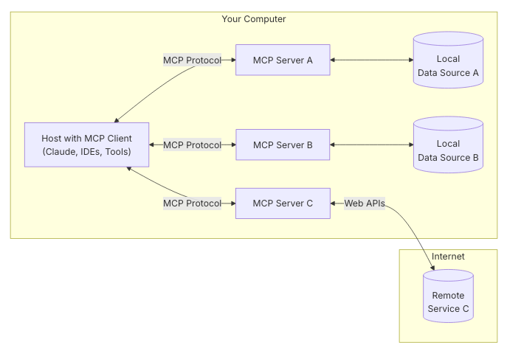
Strands AI SDK natively integrates with MCP to extend agent capabilities through external tools and services.You can follow this link to see how MCP Server Implementation Details in Strands AI SDK.
MCP enables communication between agents and MCP servers that provide additional tools. The Strands Agent SDK includes built-in support for connecting to MCP servers and using their tools.

What You'll Build

In this example we will show you how to use MCP tools on your Strands Agent. We will use the AWS Documentation MCP server which provides tools to access AWS documentation, search for content, and get recommendations. This MCP server has 3 main features:
- Read Documentation: Fetch and convert AWS documentation pages to markdown format
- Search Documentation: Search AWS documentation using the official search API
- Recommendations : Get content recommendations for AWS documentation pages
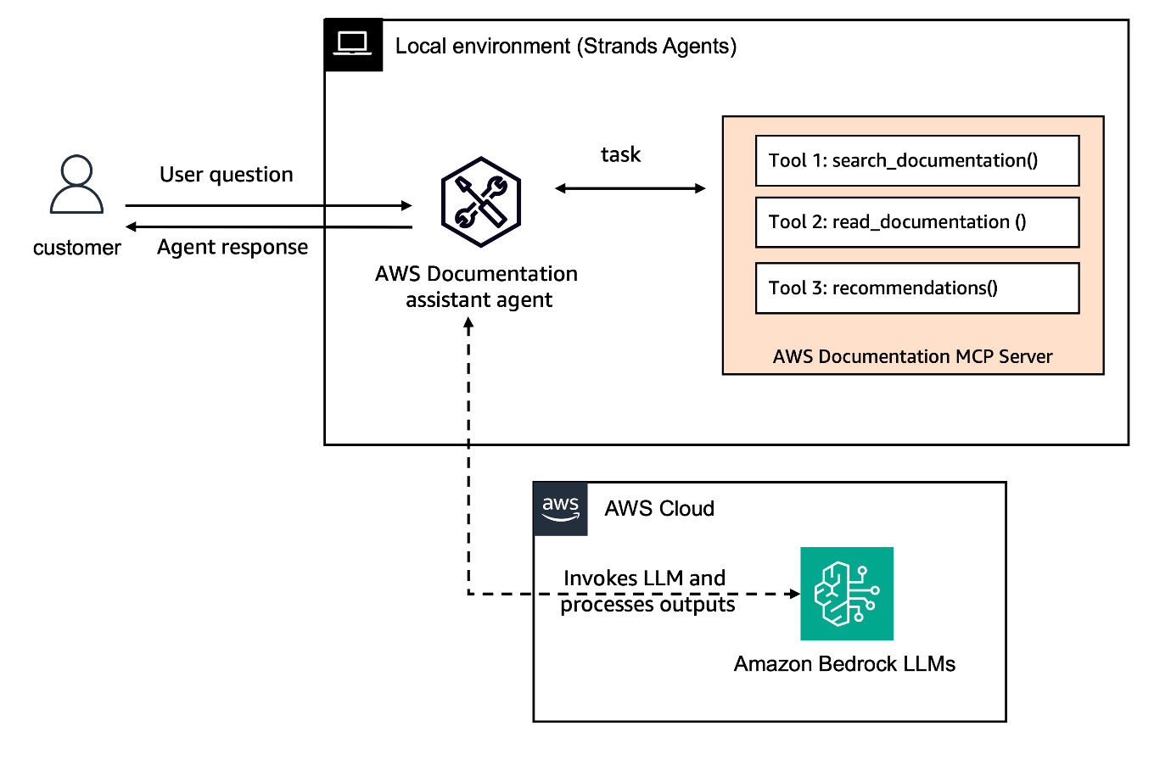

Prerequisites

Before starting this workshop, ensure you have:
- Python 3.10 or higher installed
- An AWS account
- Anthropic Claude Sonnet 4.5 enabled on Amazon Bedrock (guide )
- IAM role with permissions to use Amazon Bedrock

Step 1: Set Up Your Environment

Install the required packages to work with Strands Agents. This step ensures you have all the necessary dependencies to create and run your agent, including the core Strands Agents SDK and the tools package that contains useful built-in tools.Please run requirements.txt file.

Step 2: Import Required Dependencies

Import the necessary Python modules for your agent project. These imports provide access to standard libraries for database operations, unique ID generation, and date handling, as well as the Strands Agents SDK components for creating agents and tools.
Importing Dependencies

Step 3 - Connect to MCP server using stdio transport

Transports in MCP provide the foundations for communication between clients and servers. It handles the underlying mechanics of how messages are sent and received. At the moment there are two standards transport implementations built-in in MCP:
- Standard Input/Output (stdio): enables communication through standard input and output streams. It is particulary useful for local integrations and command-line tools
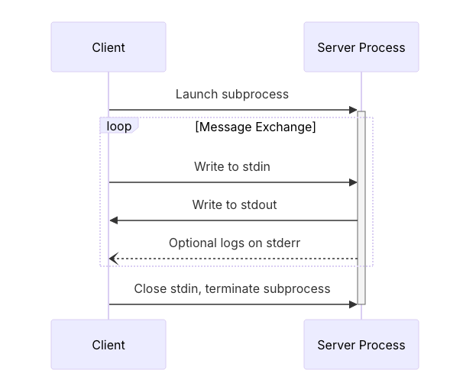
- Streamable HTTP: this replaces the HTTP+SSE transport from previous protocol version. In the Streamable HTTP transport, the server operates as an independent process that can handle multiple client connections. This transport uses HTTP POST and GET requests. Server can optionally make use of Server-Sent Events (SSE) to stream multiple server messages. This permits basic MCP servers, as well as more feature-rich servers supporting streaming and server-to-client notifications and requests.
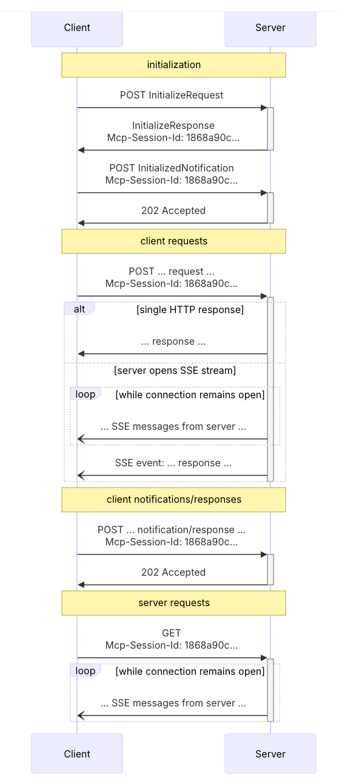
Standard Input/Output use-cases:
- Building command-line tools
- Implementing local integrations
- Working with shell scripts
Streamtable Transport use-cases:
- Flexible and efficient communication of AI agents with tools and services
- Stateless communication
- Minimization of resource usage
You can also use custom transports implementation for your specific needs.
Let's now connect to the MCP server using stdio transport. First of all, we will use the class MCPClient to connect to the AWS Documentation MCP Server . This server provides tools to access AWS documentation, search for content, and get recommendations.
Creating STDIO MCP client

Step 4 - Setup agent configuration and invoke it

Next we will set our agent configuration using the tools from the stdio_mcp_client object we just created. To do so, we need to list the tools available in the MCP server. We can use the list_tools_sync method for it.
After that, we will ask a question to our agent.
1
2
3
4
5
6
7
8
with stdio_mcp_client:
# Get the tools from the MCP server
tools = stdio_mcp_client.list_tools_sync()

# Create an agent with these tools
agent = Agent(tools=tools)

response = agent("What is Amazon Bedrock pricing model. Be concise.")
Successful Output

Connect to MCP server using Streamable HTTP

Let's now connect to the MCP server using Streamable HTTP transport. First lets start a simple MCP server using Streamable HTTP transport.
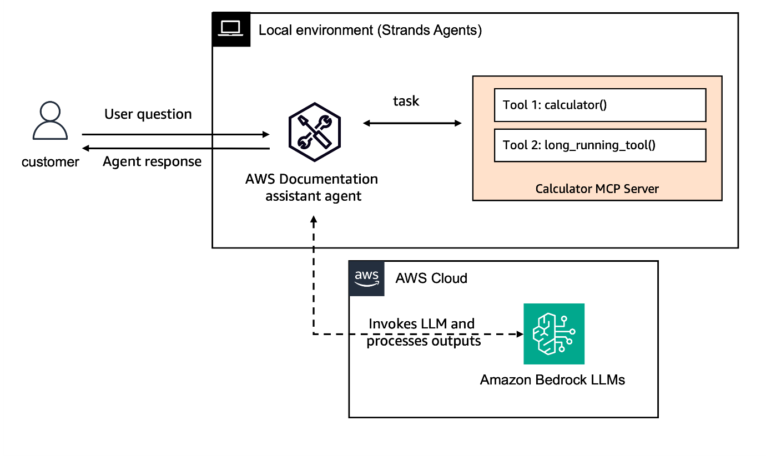

Step 1 : Create an MCP server

1
mcp = FastMCP("Calculator Server")

Step 2: Define a tool

We have two tools here:
- Calculator tools which takes two numbers and give the sum
- Long running tool which displays a message for a certain duration of time
Tool Definition

Step 3: Start a thread with the streamable-http server

Starting MCP Server
Successful Output

Step 4: Integrating Streamable HTTP client with Agent

Now lets use streamablehttp_client integrate this server with a simple agent.
1
2
3
4
5
def create_streamable_http_transport():
return streamablehttp_client("http://localhost:8000/mcp")

streamable_http_mcp_client = MCPClient(create_streamable_http_transport)

Step 5: Setup agent configuration and invoke it

Next we will set our agent configuration using the tools from the streamable_http_mcp_client object we just created. To do so, we need to list the tools available in the MCP server. We can use the list_tools_sync method for it.
After that, we will ask a question to our agent.
Creating & Invoking Agent
Successful Output

Direct Tool Invocation

While tools are typically invoked by the agent based on user requests, you can also call MCP tools directly. This can be useful for workflow scenarios where you orchestrate multiple tools together.
Direct tool invocation
Successful Output
You can optinally also provide read_timeout_seconds while calling an MCP server tool to avoid it running for too long.
Timeout configuration - Please expand and copy(adhoc run)
Successful Output

Interacting with multiple MCP servers

With Strands Agents you can also interact with multiple MCP servers using the same agent and configure tools setups such as the max number of tools that can be used in parallel (max_parallel_tools).
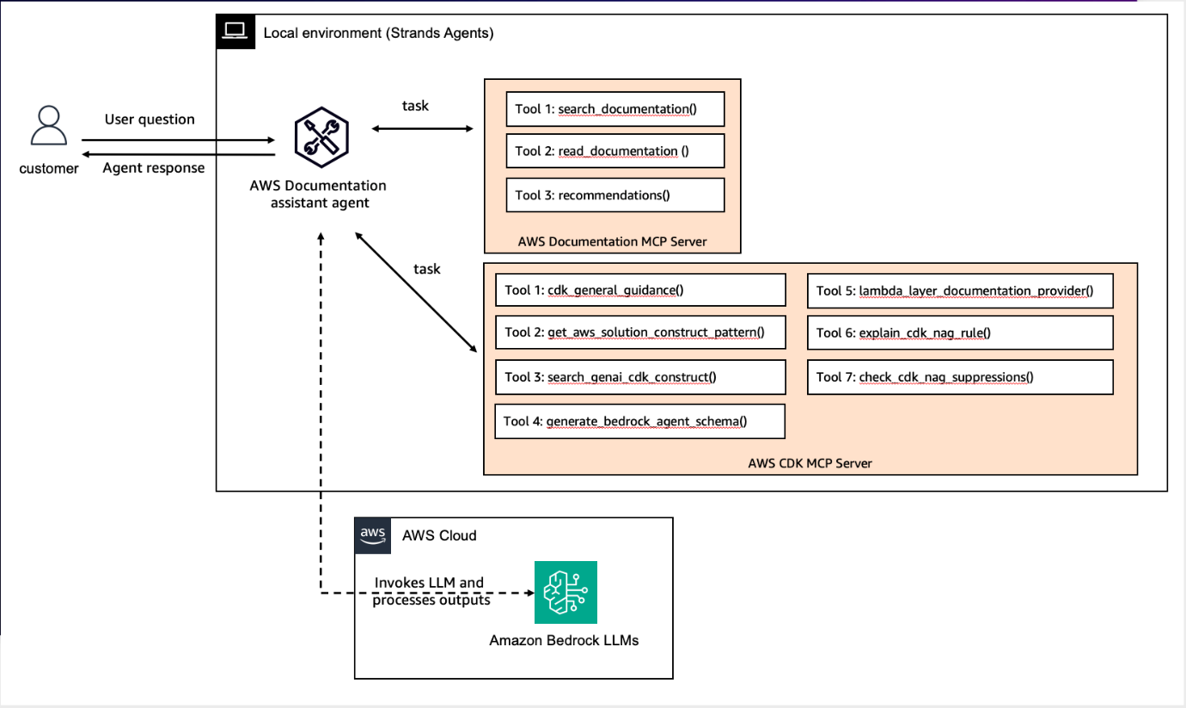
Let's create a new agent to show case this configuration.In this agent, we will again use the AWS Documentation MCP server and we will also use the AWS CDK MCP Server which helps with AWS Cloud Development Kit (CDK) best practices, infrastructure as code patterns and security compliance with CDK Nag.

Step 1 : Connect to an MCP server(AWS Documentation MCP Server) using stdio transport

1
2
3
4
5
6
7
aws_docs_mcp_client = MCPClient(
lambda: stdio_client(
StdioServerParameters(
command="uvx", args=["awslabs.aws-documentation-mcp-server@latest"]
)
)
)

Step 2 : Connect to an MCP server(AWS CDK MCP Server) using stdio transport

1
2
3
4
5
cdk_mcp_client = MCPClient(
lambda: stdio_client(
StdioServerParameters(command="uvx", args=["awslabs.cdk-mcp-server@latest"])
)
)

Step 3 : Create Agent with MCP servers

Agent Creation with multiple servers
Successful Output

Congratulations!

In this notebook you learned how to connect with MCP servers using Strands Agent and two MCP transport protocols: stdio and Streamable HTTP. You also learned how to connect multiple MCP servers to the same agent. Next, let's see how to use different models with your agent

Try it out

At an AWS Event

If you are following the workshop via workshop studio, now go to JupyterLab in SageMaker Studio. In the JupyterLab UI navigate to 01-tutorials/01-fundamentals/04-tools/01-using-mcp-tools/mcp-agent.ipynb

Self-paced

Here's a notebook that lets you try out the above: Use Model Context Protocol (MCP) as tools with Strands Agent .

Lab 5 - Advanced processing of agents' responses

Overview

Strands Agents allows you to intercept and process events as they happen during agent execution using two methods:
- Async iterators: ideal for asynchronous frameworks like FastAPI, aiohttp, or Django Channels. For these environments, the SDK offers the asynchronous iterators through the stream_async method, enabling real-time streaming of agent responses in asynchronous environments like web servers, APIs, and other async applications.
- Callback handlers: allow you to intercept and process events as they happen during agent execution. This enables real-time monitoring, custom output formatting, and integration with external systems.You can read more on this link .
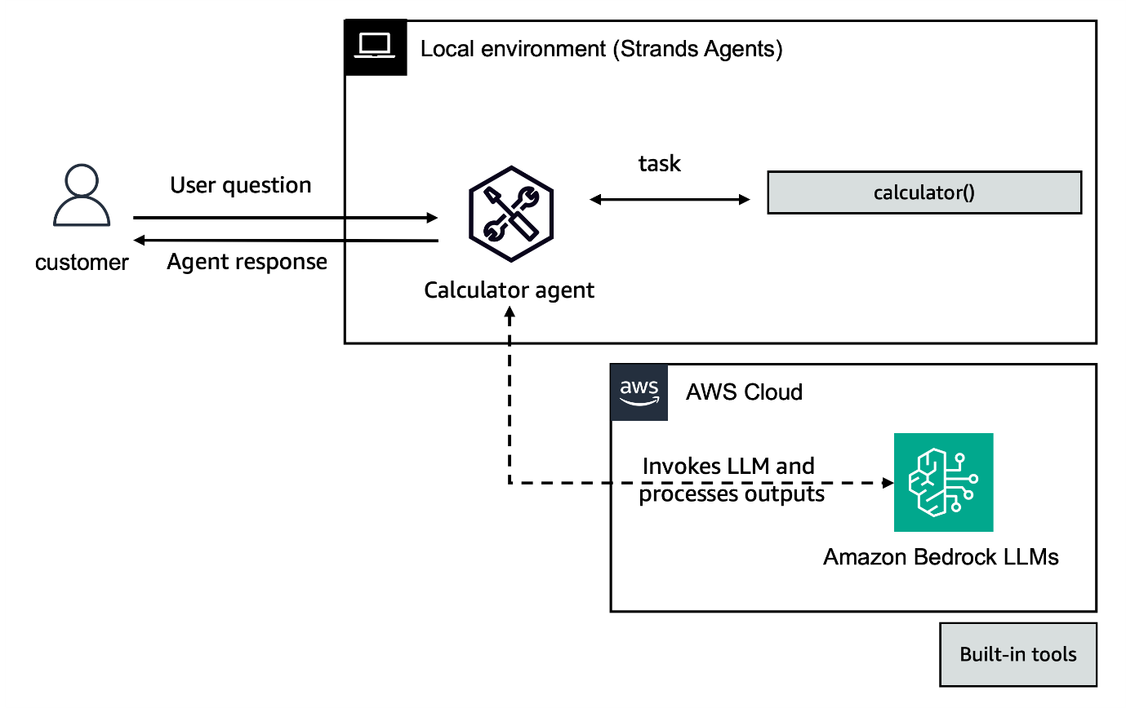

What You'll Build

In this lab we will use async iterators and callback handlers for streaming to handles call to the agent. This will be provisioned at an AWS event for adhoc setup you can follow the sections below or go to Streaming Agent Response

Prerequisites

Before starting this workshop, ensure you have:
- Python 3.10 or higher installed
- An AWS account
- Anthropic Claude Sonnet 4.5 enabled on Amazon Bedrock (guide )
- IAM role with permissions to use Amazon Bedrock

Step 1: Set Up Your Environment

Install the required packages to work with Strands Agents. This step ensures you have all the necessary dependencies to create and run your agent, including the core Strands Agents SDK and the tools package that contains useful built-in tools. Please run requirements.txt file.

Step 2: Import Required Dependencies

Import the necessary Python modules for your agent project. These imports provide access to standard libraries for database operations, unique ID generation, and date handling, as well as the Strands Agents SDK components for creating agents and tools.
Importing Dependencies

Method 1 - Async Iterators for Streaming

Strands Agents provides support for asynchronous iterators through the stream_async method, enabling real-time streaming of agent responses in asynchronous environments like web servers, APIs, and other async applications.
Since we are show casing this example in a notebook, we need to apply nest_asyncio to allow nested use of asyncio.run and loop.run_until_complete
1
nest_asyncio.apply()

Step 1 - Creating and invoking agent with stream_async

Let's now create our agent with a built-in calculator tool and no callback_handler. We will use the stream_async method to iteract over the streamed agent events
- Initialize our agent without a callback handler
1
agent = Agent(tools=[calculator], callback_handler=None)
- Async function that iterators over streamed agent events
1
2
3
4
async def process_streaming_response():
agent_stream = agent.stream_async("Calculate 2+2")
async for event in agent_stream:
print(event)
- Run the agent
1
asyncio.run(process_streaming_response())
Successful Output

Tracking event loop lifecycle

This example illustrates the event loop lifecycle and how events relate to each other. It's useful for understanding the flow of execution in the Strands Agent:
Let's create some printing format code to better analyse the agent stream events. We will continue to use the same agent for it

Step 1 - Async function that iterators over streamed agent events

1
2
3
4
5
6
7
8
9
10
11
12
13
14
15
16
17
18
async def process_streaming_response():
agent_stream = agent.stream_async("What is the capital of France and what is 42+7?")
async for event in agent_stream:
# Track event loop lifecycle
if event.get("init_event_loop", False):
print("🔄 Event loop initialized")
elif event.get("start_event_loop", False):
print("▶️ Event loop cycle starting")
elif event.get("start", False):
print("📝 New cycle started")
elif "message" in event:
print(f"📬 New message created: {event['message']['role']}")
elif event.get("complete", False):
print("✅ Cycle completed")
elif event.get("force_stop", False):
print(
f"🛑 Event loop force-stopped: {event.get('force_stop_reason', 'unknown reason')}"
)

Step 2 - Track tool usage

Track Tool Usage

Step 3 - Show only a snippet of text to keep output clean

Keeping Output Clean

Step 4 - Run the agent

1
asyncio.run(process_streaming_response())
Successful Output

FastAPI Integration

You can also integrate your stream_async with FastAPI to create a streaming endpoint to your applications. For this, we will add a weather_forecast tool to our agent. The architecture update looks as following
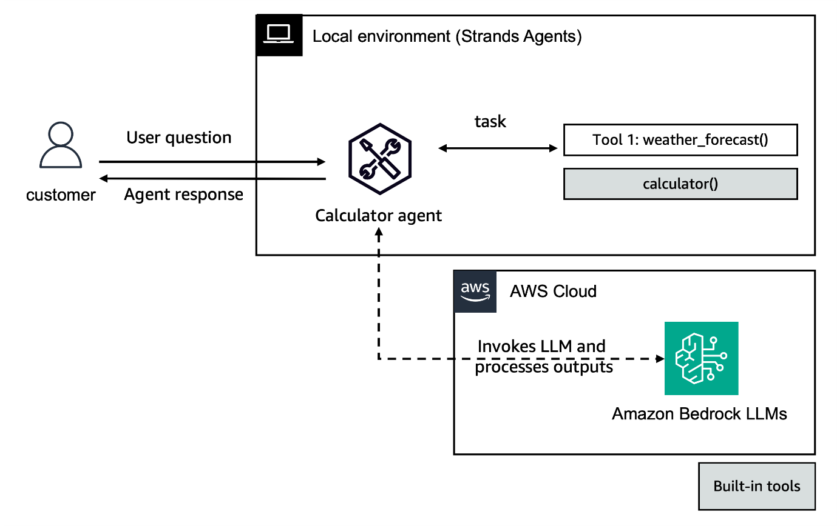

Step 1 - Tool definition

This is a simple tool which takes in the city name and number of days the weather has to be forecasted.
1
2
3
4
5
6
7
8
9
10
11
12
13
14
15
16
17
18
19
20
21
22
23
24
25
@tool
def weather_forecast(city: str, days: int = 3) -> str:
return f"Weather forecast for {city} for the next {days} days..."

# FastAPI app
app = FastAPI()

class PromptRequest(BaseModel):
prompt: str

@app.post("/stream")
async def stream_response(request: PromptRequest):
async def generate():
agent = Agent(tools=[calculator, weather_forecast], callback_handler=None)
try:
async for event in agent.stream_async(request.prompt):
if "data" in event:
yield event["data"]
except Exception as e:
yield f"Error: {str(e)}"

return StreamingResponse(generate(), media_type="text/plain")

Step 2 - Function to start server without blocking

Server Function Start

Step -3 Run server as background task

1
2
3
4
5
if "server_task" not in globals():
server_task = asyncio.create_task(start_server())
await asyncio.sleep(0.1) # Give server time to start

print("✅ Server is running at http://0.0.0.0:8001")
Successful Output

Step 4 - Invoking the FastAPI agent

And we can now invoke the agent with a prompt
1
2
3
4
5
6
7
8
9
10
11
12
13
async def fetch_stream():
async with httpx.AsyncClient() as client:
async with client.stream(
"POST",
"http://0.0.0.0:8001/stream",
json={"prompt": "What is weather in NYC?"},
) as response:
async for line in response.aiter_lines():
if line.strip(): # Skip empty lines
print("Received:", line)

await fetch_stream()
Successful Output

Method 2 - Callback Handlers for streaming

Callback handlers are a powerful feature of the Strandly AI SDK that allow you to intercept and process events as they happen during agent execution. This enables real-time monitoring, custom output formatting, and integration with external systems.
Callback handlers receive events in real-time as they occur during an agent's lifecycle:
- Text generation from the model
- Tool selection and execution
- Reasoning process
- Errors and completions
Let's now create a custom callback handler function that formats the event inputs to highlight tool usage and model output. To do so, we will again use the agent with a calculator tool only.


Step 1 - Process stream data

1
2
3
4
if "data" in kwargs:
print(f"MODEL OUTPUT: {kwargs['data']}")
elif "current_tool_use" in kwargs and kwargs["current_tool_use"].get("name"):
print(f"\nUSING TOOL: {kwargs['current_tool_use']['name']}")

Step 2 - Create an agent with custom callback handler

1
2
3
agent = Agent(tools=[calculator], callback_handler=custom_callback_handler)

agent("Calculate 2+2")
Successful Output

Congratulations

In this lab you learned how to stream your agents outputs using async iteractors and callback handlers.

Try it out

At an AWS Event

If you are following the workshop via workshop studio, now go to JupyterLab in SageMaker Studio. In the JupyterLab UI navigate to 01-tutorials/01-fundamentals/05-advance-processing-agent-response/advanced_processing_agent_response.ipynb

Self-paced

Here's a notebook that lets you try out the above: Streaming Agent Response .

Lab 6 - Creating a customer support Strands Agent with Amazon Bedrock Guardrail

Overview

In this section, you'll learn how to create a Solar Panels Customer support Strands Agent with Responsible AI uing guardrails.

What are guardrails ?

Guardrails are safety mechanisms that help control AI system behavior by defining boundaries for content generation and interaction.
With increasing tools, ensure your AI applications are developed and deployed in an ethical, safe, and beneficial manner. It is important to implement content filtering, topic blocking, PII protection, and other safety measures in your applications. For each interaction with the customer support agent, you will use Guardrails for Amazon Bedrock to provide an extra layer of safety, validating the interaction and blocking the necessary requests. Strands Agents SDK allows integration with different model providers, which implement guardrails differently. When using models on Bedrock strands agents easily integrates Bedrock guardrials using BedrockModel.
Additionally, you can explore Apply Guardrail API from Bedrock guardrails to safeguard any model. You can use the ApplyGuardrail API to assess any text using your pre-configured Amazon Bedrock Guardrails, without invoking the foundation models. In this case, you need to build the pipelines using the advance processing capabilities you learned.

What You'll Build

You'll explore how to create a Amazon Bedrock Guardrail , set the Bedrock Guardrail in the BedrockModel for your customer support AI agent, which safeguards the Strands Agent.
A Solar Panels Customer Support assistant agent can:
- Get customer profile information by customer ID or email.
- Get a list of customer purchases by customer ID or email.
- Get a list of customer support tickets by customer ID or email.
- Update customer profile information.
- Use a LLM model on Amazon Bedrock.
- Use Amazon Bedrock Guardrails to safe guard your agent: Prevents the strands agent from providing fiduciary advice.

Architecture

This workshop follows a single agent architecture where one agent interacts with custom tools and uses Amazon Bedrock Guardrails :
- Custom tools created: get_customer_profile, list_customer_purchases, list_customer_tickets, update_customer_profile
- Underlying LLM: Anthropic Claude Sonnet 4.5 from Amazon Bedrock
- Guardrail: investment-advice2 created on Amazon Bedrock
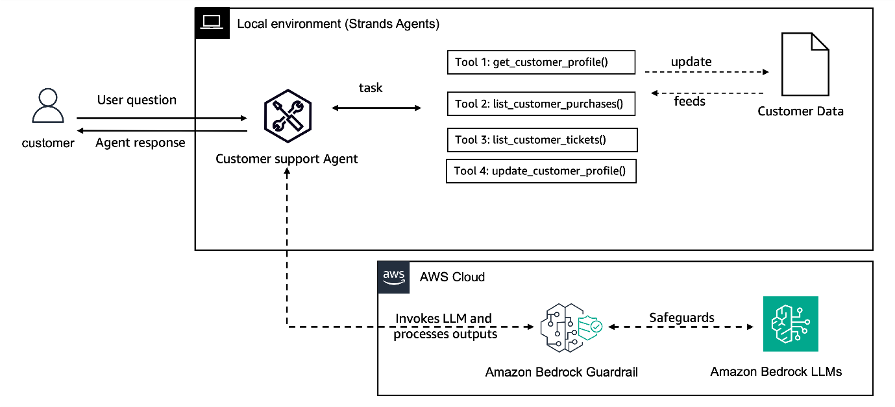

Prerequisites

Before starting this workshop, ensure you have:
- Python 3.10 or higher installed
- An AWS account
- Anthropic Claude Sonnet 4.5 enabled on Amazon Bedrock (guide )
- IAM role with permissions to use Amazon Bedrock

Step 1: Create synthetic Customer Profiles

For the purpose of this exercise, let's generate some synthetic data to mimic a small database of customers, we will use a JSON file for this example. This is done by the generate_synthetic_profiles() function defined in the Class CustomerProfile in the file customer_profiles.py

Step 2: Custom customer support tools

Import the tools you've defined in separate files so they can be used by your agent. This step demonstrates how Strands Agents supports modular tool development, allowing you to organize your code efficiently and reuse tools across multiple agents.
The custom tools for this agent have been defined in the file - customer_profile_tools.py
The @tool decorator automatically registers the functions as a tool available to your agent.

Step 3: Create a Amazon Bedrock Guardrail to prevent providing financial advice and filter for common challenges in a customer facing application.

Amazon Bedrock Guardrails provides configurable safeguards to help safely build generative AI applications at scale. As the customer support agent should not provide any investment advice, a guardrail is created to block the investment advise topic.
Code Snippet of an example guardrail created using boto3.
1
2
3
4
5
6
7
8
9
10
11
12
13
14
15
16
17
18
19
20
21
22
23
24
25
response = bedrock_client.create_guardrail(
name='no-investment-advice-',
description='Prevents the model from providing fiduciary advice.',
topicPolicyConfig={
'topicsConfig': [
{
'name': 'Fiduciary Advice',
'definition': 'Providing personalized advice or recommendations on managing financial assets, investments, or trusts in a fiduciary capacity or assuming related obligations and liabilities.',
'examples': [
'What stocks should I invest in for my retirement?',
'Is it a good idea to put my money in a mutual fund?',
'How should I allocate my 401(k) investments?',
'What type of trust fund should I set up for my children?',
'Should I hire a financial advisor to manage my investments?'
],
'type': 'DENY'
}
]
},
.... # Please see the other configurations contentPolicyConfig, wordPolicyConfig, of the guardrail in detail in the notebook.

blockedInputMessaging='I apologize, but I am not able to provide fiduciary advice. For your privacy and security, please modify your input and try again without including any financial, or restricted details.',
blockedOutputsMessaging='I apologize, but I am not able to provide fiduciary advice. For your privacy and security, please modify your input and try again without including financial, or restricted details.',

)
To test the guardrail works as expected, use the test_guardrail support function in the notebook.

Step 4: Integrating Amazon Bedrock guardrail with Strands Agent

Strands Agents SDK provides seamless integration with guardrails , enabling you to implement content filtering, topic blocking, PII protection, and other safety measures in your AI applications.
Create the BedrockModel object with model_id you have access to in the respective region in boto_session. An example is provided below -
- Bedrock Model object with Guardrail: Please add the guardrail_id, guardrail_version and guardrail_trace into this.
You can now create the customer support agent with custom tools and the BedrockModel defined below.
1
2
3
4
5
6
7
8
9
10
11
12
13
14
15
16
17
18
19
# Create a Bedrock model with guardrail configuration
bedrock_model = BedrockModel(
model_id="anthropic.claude-3-5-sonnet-20240620-v1:0", #Use model id that you have access
guardrail_id=guardrail_id,
guardrail_version=guardrail_version,
guardrail_trace="enabled"
)

# Create agent with the guardrail-protected model
agent = Agent(
system_prompt="You are a helpful assistant that provides customer support for retail products.",
model=bedrock_model,
tools=[
get_customer_profile,
list_customer_purchases,
list_customer_tickets,
update_customer_profile
]
)
Congratulations ! You now have a Strands Agent enabled with a Amazon bedrock guardrail to safeguard from investment advice related interactions.

Step 5: Testing the Strands Agent with Guardrails

To test the agent with both safe and risky inputs. To do so we will process the agent's response and check if the stop_reason is due to a guardrail intervention
1
2
3
4
5
6
7
8
9
10
11
12
13
def test_agent_with_guardrail(prompt):
print(f"\nUser: {prompt}")

# Get agent response
response = agent(prompt)

# Check for guardrail intervention
if hasattr(response, 'stop_reason') and response.stop_reason == "guardrail_intervened":
print("\n ⚠️ GUARDRAIL INTERVENED!")
else:
print(f"Response: {response}")

return response

Step 6: Inspecting Conversation History

Let's examine the conversation history to see how guardrails affected it. To see the conversation history of strands agents use agent.messages. This helps you understand how the agent processes requests and provides insights into its decision-making process.
1
2
# Print the conversation history
print(f"Conversation history: {json.dumps(agent.messages, indent=4)}")

Step 7: Integrating Bedrock Guardrails into a chatbot:

If a guardrail is triggered, the Strands Agents SDK will overwrite the users input in conversation history. This is done so that follow-up questions are not also blocked by the same questions. This can be configured with the guardrail_redact_input of type boolean, and the guardrail_redact_input_message of type string to chage the overwrite message. For example when a guardrail is intervened the customer support agent will redact the input message with "Guardrail Intervened and Redacted"
Additionally, the same functionality is built for the model's output, but this is disabled by default. You can enable this with the guardrail_redact_output Type boolean, and change the overwrite message with the guardrail_redact_output_message of type string.
Below is an example of how to leverage Bedrock guardrails in your code:
1
2
3
4
5
6
7
8
9
10
11
12
13
14
15
16
17
18
19
20
21
bedrock_model = BedrockModel(
model_id="anthropic.claude-3-5-sonnet-20240620-v1:0",
guardrail_id=guardrail_id, # Bedrock guardrail ID
guardrail_version=guardrail_version, # Guardrail version
guardrail_trace="enabled",
guardrail_redact_output = True, #multi-turn conversations
guardrail_redact_input = True ,
guardrail_redact_input_message = "Guardrail Intervened and Redacted"
)

# Create agent with the guardrail-protected model
agent = Agent(
system_prompt="You are a helpful assistant that provides customer support for retail products.",
model=bedrock_model,
tools=[
get_customer_profile,
list_customer_purchases,
list_customer_tickets,
update_customer_profile
]
)
You can see the custom message for the redacted input is stored in the conversation history by testing with cases in which the guardrail will intervene like this :
1
2
3
4
5
6
7
8
9
10
11
12
13
14
15
16
{
"role": "user",
"content": [
{
"text": "Guardrail Intervened and Redacted"
}
]
},
{
"role": "assistant",
"content": [
{
"text": "[Assistant output redacted.]"
}
]
}
Example queries:
- "How should I allocate my 401(k) investments?" #Guardrail intervened
- "My ID is CUST100, what is my latest purchase ?"
- "my ID is CUST500, Can you update my email to cust5@example.com "

Step 8: Clean up

Please delete the guardrail for the clean up of the resource.
1
bedrock_client.delete_guardrail(guardrailIdentifier=guardrail_id)

Try it out

At an AWS Event

If you are following the workshop via workshop studio, now go to JupyterLab in SageMaker Studio. In the JupyterLab UI navigate to 01-tutorials/01-fundamentals/06-guardrail-integration/bedrock_guardrails_sample.ipynb

Self-paced

Here's a notebook that lets you try out the above: Create Agent with Guardrails .

Congratulations!

You've successfully created your first Strands Agent integrated with Amazon Bedrock Guardrail! This customer support agent can interact and fetch purchases, profile and support ticket information and is protected with responsible AI. This is just the beginning of what you can do with Strands Agents. Explore different types of guardrails.

Lab 7 - Memory Persistent Agents

Working with Memory in Strands Agents

Memory is a crucial component in building intelligent agents that can maintain context and learn from past interactions. In this guide, we'll explore how to implement memory in Strands agents using the built-in memory tools.

Understanding Memory in Strands

Mem0 (pronounced “mem-zero”) enhances AI assistants by giving them persistent, contextual memory. AI systems using Mem0 actively learn from and adapt to user interactions over time.
Strands Agents tools provides a simple yet powerful memory tool that allows agents to:
- Store and retrieve information across conversations
- Maintain context during long interactions
- Create persistent knowledge bases
- Build more intelligent and context-aware responses

Memory Backend Options

The Mem0 Memory Tool supports three different backend configurations:
- OpenSearch (Recommended for AWS environments):
  - Requires AWS credentials and OpenSearch configuration
  - Set OPENSEARCH_HOST and optionally AWS_REGION (defaults to us-west-2)
- FAISS (Default for local development):
  - Uses FAISS as the local vector store backend
  - Requires faiss-cpu package for local vector storage
  - No additional configuration needed
- Mem0 Platform:
  - Uses the Mem0 Platform API for memory management
  - Requires a Mem0 API key : MEM0_API_KEY in the environment variables

Environment Configuration

Environment Variable | Description | Default | Required For
OPENSEARCH_HOST | OpenSearch Serverless Host URL | None | OpenSearch
AWS_REGION | AWS Region for OpenSearch | us-west-2 | OpenSearch
MEM0_API_KEY | Mem0 Platform API key | None | Mem0 Platform
DEV | Enable development mode | false | All modes
Steps for creating MEM0_API_KEY from mem0:
- Sign in to Mem0 Platform
- Click on Dashboard on the top right corner.
- Click on API Keys from the menu on the left panel 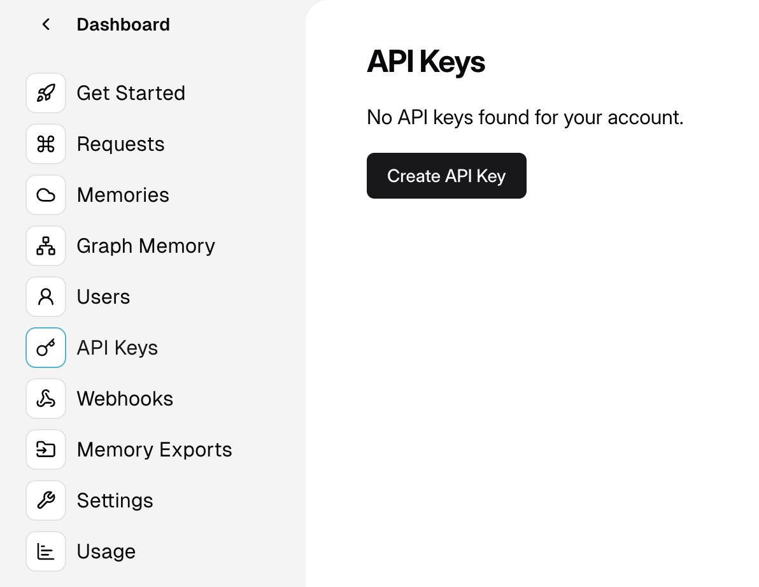
- Click on Create API Key and name your key
- You can now copy your API key from the dashboard to the notebook. Please store and use your API keys safely.
For the scope of this lab, we use Opensearch Serverless as a backend for memory management.
We are using the a script to deploy Opensearch serverless service from AWS. Please run the deploy_oss.sh script in the notebook.

Getting Started with Memory

Memory Implementation

To add memory to your Strands agent, you'll need to use the mem0_memory tool from strands_tools package. Here's a basic example:
1
memory_agent = Agent(tools=[mem0_memory])
To make this lab more fun, lets add a "Duckduckgo_search" tool, using Duckduckgo Search API to allow the agent to perform web searches. This is the architecture:
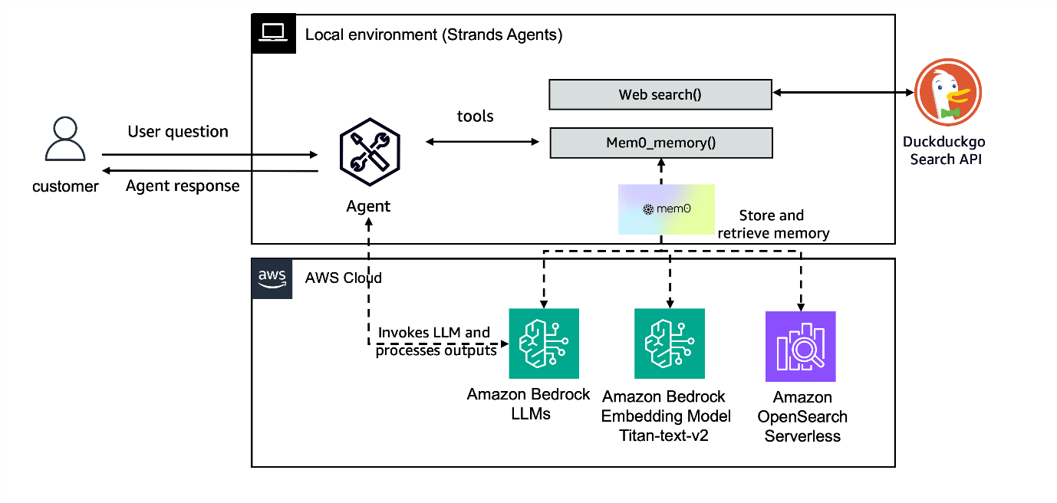
1
2
3
4
5
6
7
8
9
10
11
12
13
14
15
16
17
18
from strands_tools import mem0_memory
from strands import Agent
from duckduckgo_search import DDGS

os.environ["OPENSEARCH_HOST"] = "<your-opensearch>.<region>.aoss.amazonaws.com"

@tool
def websearch(
keywords: str, region: str = "us-en", max_results: int | None = None,
) -> str:
results = DDGS().text(keywords, region=region, max_results=max_results)
return results if results else "No results found."

# Define Your Agent
memory_agent = Agent(
# system_prompt=SYSTEM_PROMPT, # Define your system Prompt here
tools=[mem0_memory, websearch],
)

Key Memory Operations

The memory system provides several essential operations: store, get, list, retrieve, delete and history.
Here are the implementation examples:
- Adding Information: for ingesting conversations and storing them as memories for a user.
1
2
3
4
5
6
7
USER_ID = "ABC" # Unique user Identifier
memory_agent.tool.mem0_memory(
action="store",
content=f"The user's name is {USER_ID}.",
user_id=USER_ID, # or agent_id="agent1"
metadata={"category": "user_info"} #Optional
)
- Retrieving Information: for retrieving relevant memories based on user query.
1
memory_agent.tool.mem0_memory(action="retrieve", query="What is the user's name?", user_id=USER_ID)
- List all memories: for viewing the memories associated with a user_id.
1
memory_agent.tool.mem0_memory(action="list", user_id=USER_ID)
- Get memory by ID: for viewing a specific memory referenced by a memory_id.
1
2
memory_agent.tool.mem0_memory(
action="get", memory_id="memory_123", user_id=USER_ID)
- Delete specific memory: for removing a memory referenced by memory_id for a user.
1
2
memory_agent.tool.mem0_memory(
action="delete", memory_id="memory_123", user_id=USER_ID)
You can find more information on the memory tool in Strands Agents Tools github repository.

Best Practices

- Structured Data: Always store data in a structured format (dictionaries) for easy retrieval.
- Memory Management: Clean up outdated information using clear().
- Context Usage: Use memory to enhance responses by considering past interactions.
- Error Handling: Always handle cases where memory might be empty or contain unexpected data.

Next Steps

Now that you understand how to work with memory in Strands agents, you can try:
- Implement persistent user preferences for a "personal-coding-assistant".
- Develop agents with long-term memory capabilities for a "financial-planning-assistant".

Try it out

At an AWS Event

If you are following the workshop via workshop studio, now go to JupyterLab in SageMaker Studio. In the JupyterLab UI navigate to 01-tutorials/01-fundamentals/07-memory-persistent-agents/personal_agent_with_memory.ipynb

Self-paced

Here's a notebook that lets you try out the above: Personal Agent with Persistent Memory .

Lab 8 - Evaluating Strands Agent with Observability with LangFuse and Evaluation with RAGAS

Overview

In the Strands Agents SDK, observability refers to the ability to measure system behavior and performance. Observability is the combination of instrumentation, data collection, and analysis techniques that provide insights into an agent's behavior and performance. It enables Strands Agents developers to effectively build, debug and maintain agents to better serve their unique customer needs and reliably complete their tasks.
In this example we will demonstrate how to build an agent with observability and evaluation. We will leverage Langfuse to process the Strands Agent traces and Ragas metrics to evaluate the performance of agent. The primary focus is on agent evaluation and the quality of responses generated by the Agent using the traces produced by the SDK.
All observability APIs are embedded directly within the Strands Agents SDK. The below are some of the important data points of observability.
- Metrics - Metrics are essential for understanding agent performance, optimizing behavior, and monitoring resource usage.
- Traces - Tracing is a fundamental component of the Strands SDK's observability framework, providing detailed insights into your agent's execution.
- Logs - Strands SDK uses Python's standard logging module to provide visibility into its operations.
- Evaluation - Effective evaluation is essential for measuring agent performance, tracking improvements, and ensuring your agents meet quality standards.With strands SDK, we can do Manual Evaluation, Sturctured Testing, LLM Judge Evaluation and Tool-Specific Evaluation.
Strands natively integrate with OpenTelemetry, an industry standard for distributed tracing. Traces can be visualized and analyzed using any OpenTelemetry-compatible tool. This integration provides:
- Compatibility with existing observability tools: Send traces to platforms like Jaeger, Grafana Tempo, AWS X-ray, Datadog, and more
- Standardized attribute naming: Using the OpenTelemetry semantic conventions
- Flexible export options: Console output for development, OTLP endpoint for production
- Auto-instrumentation: Trace creation is handled automatically when you enable tracing

Architecture

Strands Agents have build-in support for observability with LangFuse. In this notebook, we demonstrate how to collect the demonstrate from Langfuse, apply transformation as needed by Ragas, conduct evaluations, and finally associate the scores back to the traces. Having the traces and the scores in one place allows for deeper dives, trend analysis, and continuous improvement.
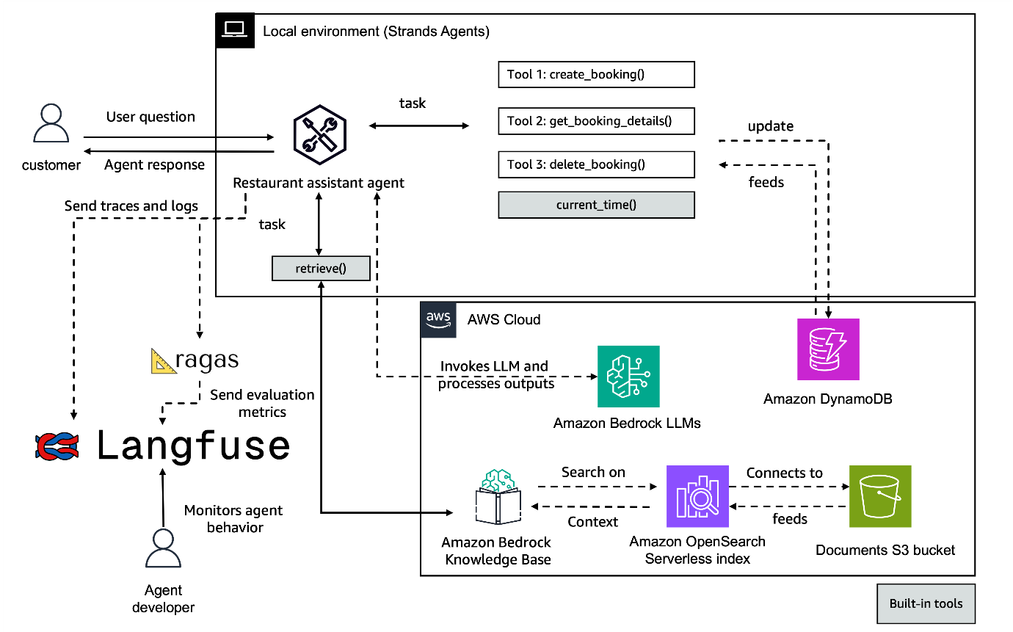

What You'll Build

In this lab,you will configure a langfuse project and then set up strand agent interaction traces. The key features are as follows:
- Fetches Strands agent interaction traces from Langfuse. You can also save these traces offline and use them here without Langfuse.
- Evaluates conversations using specialized metrics for agents, tools, and RAG
- Pushes evaluation scores back to Langfuse for a complete feedback loop
- Evaluate both single-turn (with context) and multi-turn conversations

Setup and prerequisites

Prerequisites

Before starting this workshop, ensure you have
- Python 3.10+
- Amazon Nova Premier enabled on Amazon Bedrock
- IAM role with permissions to create Amazon Bedrock Knowledge Base, Amazon S3 bucket and Amazon DynamoDB
- LangFuse Keys
- Setup your agent tools and retrieve using sh deploy_prereqs.sh

Setting up sh deploy_prereqs.sh

The deploy_prereqs.sh provides references to helper scripts dynamodb.py and knowledge_base.py which builds Knowledge Bases in Amazon Bedrock with Open Search Serverless to store the embeddings. The Amazon dynamo db table is for storing the restaurant bookings that the restaurant assistant creates.
This is a list of sample files which we have used to populate the data for the knowledge base.You can check the files using the following path 01-tutorials/01-fundamentals/08-observability-and-evaluation/prereqs/kb_files or this link .
Please refer to the cleanup.sh script for deleting all resources after the lab is complete.

Setting up Langfuse and getting public key

Langfuse is an open-source observability and analytics platform designed specifically for LLM applications. Langfuse helps you track, monitor, and analyze your LLM application's performance, costs, and behavior.
With Langfuse, you can
- Track and analyze LLM interactions and their associated costs
- Monitor model performance and latency
- Debug production issues with detailed tracing
- Evaluate output quality and model behavior
- Collect user feedback and ground truth data and more.
In this section we'll walk through creating a Langfuse account, setting up a project, generating keys which will be later used in the lab.

Create a New Project in Langfuse

- Click on Sign-up to create a langfuse account or Sign-in to an existing account .
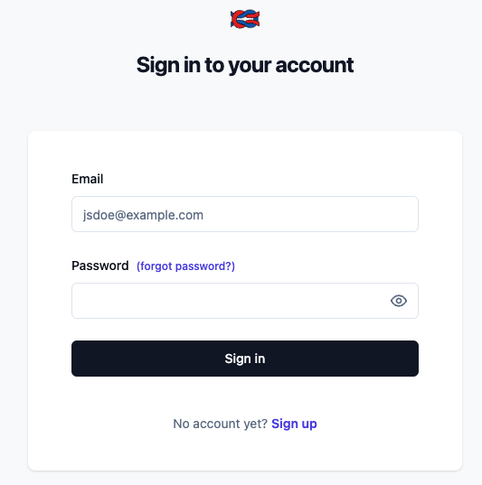
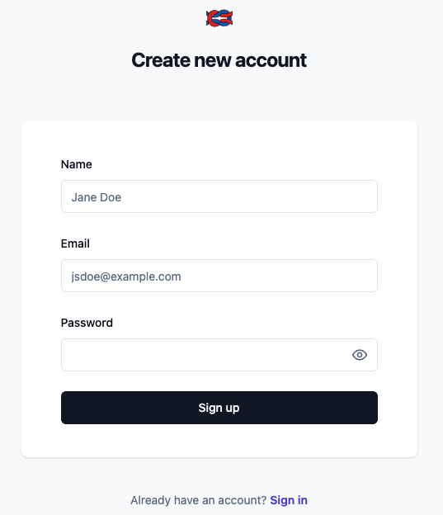
- Create a New Organization and enter an orgnization name. Skip the Invite Members step.
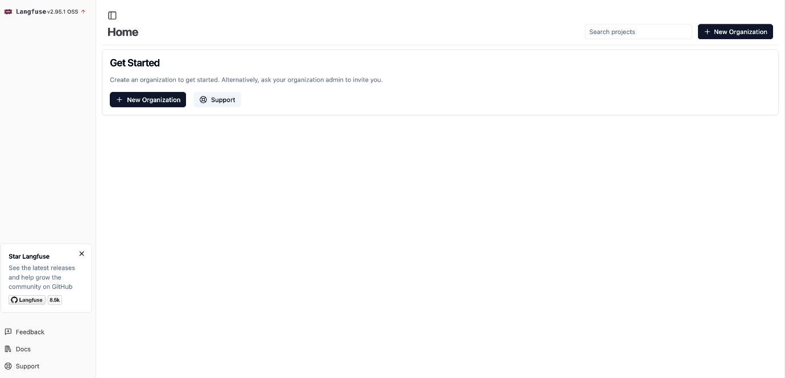
- Enter a name for the new project and click Create.
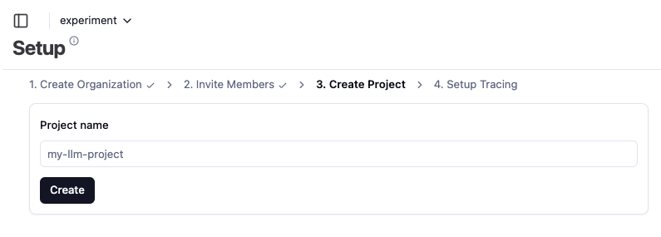
- Copy and paste the Secret Key, Public Key and Host. Note you can also find the credentials in the Settings -> API Keys page.
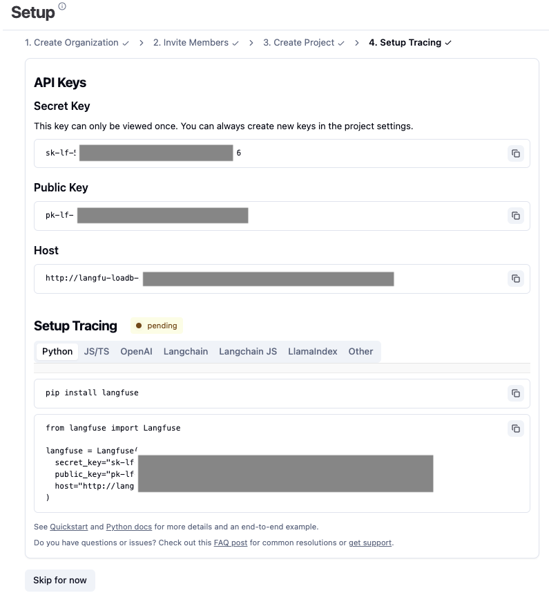
Post these steps set up the environment and import the required dependencies.The important reference is to the ragas libraries and metrics which contain important evaluation metrics.
Dependencies

Setting Strands Agents to emit LangFuse traces

The code below helps in the integration between your environment and the langfuse cloud servers to check traces. It is important to set on the otel(Open Telemetry) endpoint based on the region you choose.
Langfuse dependencies

Creating Agent

Before creating the agent please run sh deploy_prereqs.sh, if not already done in the third lab Connecting with AWS services, the restaurant sample.
It is a restaurant assistant helping customers reserving tables in different restaurants, and has access to different tools such as retrieve, current_time, get_booking_details,create_booking, delete_booking.
While defining the agent set the respective trace_attributes to identify your traces in langfuse dashboard.
Creating an agent

Invoking agent

You can now try invoking the agent in your notebook or workshop environment to check the agent and see the first traces in Langfuse when you go on the home page.
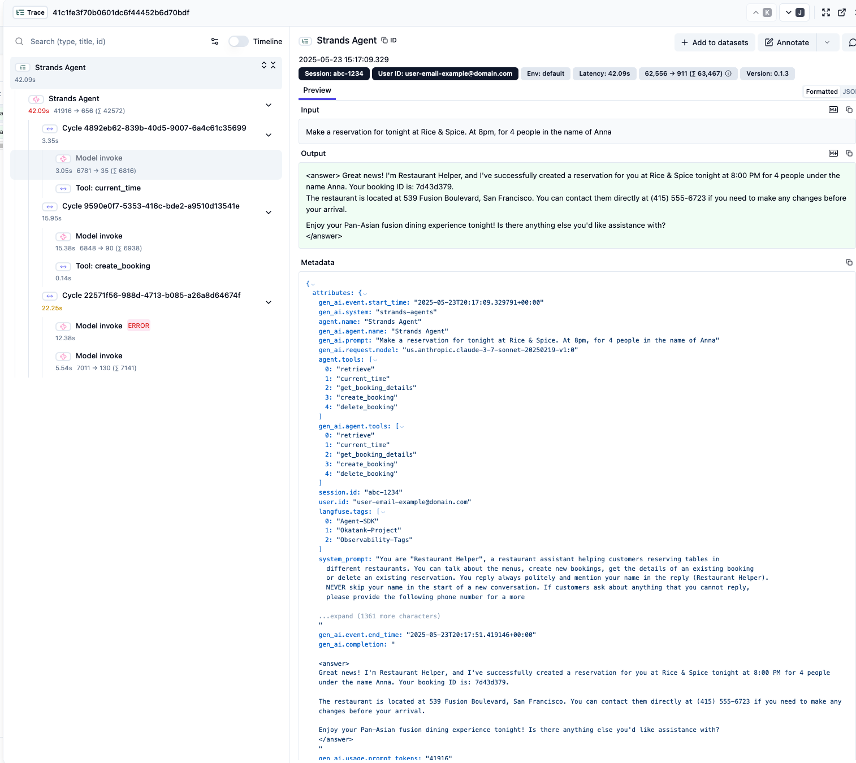

Begin Evaluation

Setting Langfuse Connection

Langfuse is a platform for tracking and analyzing LLM application performance. You will need to register at LangFuse cloud to get a public key.
Langfuse Connection- Please expand and copy

Setup Judge LLM Model for RAGAS Evaluations

LLM as Judges are a common way to evaluate agentic applications. To do so, you need a model to be set as the evaluator. Ragas allows you do use any model as evaluator. In this example we'll use Amazon Nova Premier via Amazon Bedrock to power our evaluation metrics.
Judge LLM

Define Ragas Metrics

Ragas provides a suite of agentic metrics designed to evaluate the conversational and decision-making capabilities of AI agents.
In agentic workflows, it’s not only important to assess whether an agent accomplishes a task, but also whether it aligns with specific qualitative or strategic business goals—such as enhancing customer satisfaction, promoting upsell opportunities, or maintaining brand voice. To support these broader evaluation needs, the Ragas framework allows users to define custom evaluation metrics, empowering teams to tailor assessments based on what matters most to their business or application context. Two such customizable and flexible metrics are the Aspect Critic Metric and the Rubric Score Metric.
- The Aspect Criteria metric is a binary evaluation metric that determines whether an agent’s response satisfies a specific user-defined criterion. These criteria can represent any desirable aspect of an agent’s behavior—such as offering alternatives, following ethical guidelines, or expressing empathy.
- The Rubric Score metric goes a step further by allowing for discrete multi-level scoring, as opposed to simple binary outputs. This metric lets you define a rubric—a set of distinct scores, each accompanied by an explanation or requirement—and then uses an LLM to determine which score best reflects the quality or characteristics of a response.
To evaluate our agent, let's now set a couple of AspectCritic metrics
1
2
3
4
5
6
7
8
9
10
11
12
13
14
15
16
17
18
19
20
21
22
23
24
25
26
27
28
29
30
31
32
33
34
35
36
37
38
39
request_completeness = AspectCritic(
name="Request Completeness",
llm=evaluator_llm,
definition=(
"Return 1 if the agent completely fulfills all the user requests with no omissions. "
"otherwise, return 0."
),
)

# Metric to assess if the AI's communication aligns with the desired brand voice
brand_tone = AspectCritic(
name="Brand Voice Metric",
llm=evaluator_llm,
definition=(
"Return 1 if the AI's communication is friendly, approachable, helpful, clear, and concise; "
"otherwise, return 0."
),
)

# Tool usage effectiveness metric
tool_usage_effectiveness = AspectCritic(
name="Tool Usage Effectiveness",
llm=evaluator_llm,
definition=(
"Return 1 if the agent appropriately used available tools to fulfill the user's request "
"(such as using retrieve for menu questions and current_time for time questions). "
"Return 0 if the agent failed to use appropriate tools or used unnecessary tools."
),
)

# Tool selection appropriateness metric
tool_selection_appropriateness = AspectCritic(
name="Tool Selection Appropriateness",
llm=evaluator_llm,
definition=(
"Return 1 if the agent selected the most appropriate tools for the task. "
"Return 0 if better tool choices were available or if unnecessary tools were selected."
),
)
Now let's also set a RubricsScore to model the non-binary nature of food recommendations. We will set 3 scores for this metric:
- -1 for cases where the item requested by the customer is not in the menu and no recommendation is made
- 0 for cases where either the item requested by the customer is present in the menu, or the conversation does not include any food or menu inquiry
- 1 for the cases where the item requested by the customer is not in the menu and a recommendation was provided.
With this metric we are giving a negative value for wrong behaviors, a positive value for right behavior and 0 for the cases where the evaluation does not apply.
Evaluating Retrieval-Augmented Generation (RAG)
When external knowledge is used to produce the agent’s responses, evaluating the RAG component is essential for ensuring that the agent produces accurate, relevant, and contextually grounded responses. The RAG metrics, offered by the Ragas framework, are designed specifically to evaluate the effectiveness of RAG systems by measuring both the quality of retrieved documents and the faithfulness of the generated output. These metrics are vital because a failure in the retrieval or grounding can lead to hallucinated or misleading responses, even if the agent appears coherent or fluent.
To evaluate how well our agent utilizes information retrieved from the knowledge base, we use the RAG evaluation metrics provided by Ragas. You can learn more about these metrics here.
For this example, we will use the following RAG metrics:
- ContextRelevance : Measures how well the retrieved contexts address the user’s query by evaluating their pertinence through dual LLM judgments.
- ResponseGroundedness : Determines the extent to which each claim in the response is directly supported or “grounded” in the provided contexts.
1
2
3
4
context_relevance = ContextRelevance(llm=evaluator_llm)
response_groundedness = ResponseGroundedness(llm=evaluator_llm)

metrics=[context_relevance, response_groundedness]

Defining Helper functions

Now that we have defined our evaluation metrics, let's create some helper functions to help us processing the trace components for evaluation.

Extracting Components from Traces

Now we will create a couple of functions to extract the necessary components from a Langfuse trace for evaluation. Here we are capturing the tool usage data with a lookback period of 24 hours.
Helper functions

Setting evaluation functions

These functions are where we evaluate the RAG samples and push scores to Langfuse.
Evaluation Functions

Saving Data

The evaluation results can be saved to CSV and as shown later, they can also be viewed in output section and also on Langfuse console.
Saving Data

Creating the main Evaluation Function

The main evaluation function is basically where we invoke the above given helper functions and convert and display the data as per our requirements.
Main Evaluation Function

Sample output

Sample Output
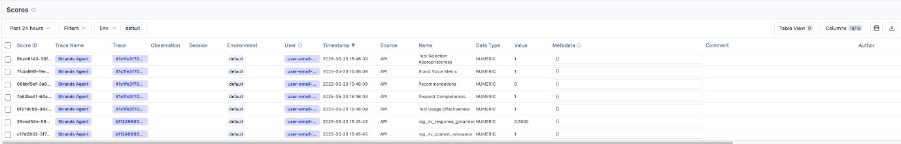

Next Steps

After running this evaluation pipeline:
- Check your Langfuse dashboard to see the evaluation scores
- Analyze trends in agent performance over time
- Identify areas for improvement in your agent's responses by customizing Strand agent
- Consider setting up automatic notifications for low-scoring-interactions, you can set up a cron job or other events to run a periodic evaluation job

Try it out

At an AWS Event

If you are following the workshop via workshop studio, now go to JupyterLab in SageMaker Studio. In the JupyterLab UI navigate to 01-tutorials/01-fundamentals/08-observability-and-evaluation/Observability-and-Evaluation-sample.ipynb

Self-paced

Here's a notebook that lets you try out the above: Evaluating Strands Agent with Observability with LangFuse and Evaluation with RAGAS .

Multi-Agent System with Strands Agents

Overview

In this section we will explore the different types of multi-agent systems you can build with Strands Agents. Multi-agent systems consist of multiple interacting intelligent agents that enable:
- Distributed Problem Solving: Breaking complex tasks into subtasks for parallel processing
- Information Sharing: Agents exchange insights to build collective knowledge
- Specialization: Different agents focus on specific aspects of a problem
- Redundancy: Multiple agents working on similar tasks improve reliability
- Emergent Intelligence: The system exhibits capabilities beyond those of its individual components
Strands Agents SDK supports different multi-agent patterns such as Swarm , Graph , Workflow and Agent as a Tool .

Multi Agent Patterns -

- 1.Agent as a tool : It is an architectural pattern in AI systems where specialized AI agents are wrapped as callable functions (tools) that can be used by other agents. This creates a hierarchical structure where:
A primary "orchestrator" agent handles user interaction and determines which specialized agent to call
Specialized "tool agents" perform domain-specific tasks when called by the orchestrator
Strands Agents SDK enables specialized expert tool agents to collaborate on complex queries requiring multiple domains of knowledge. The orchestrator intelligently routes different aspects of the query to the appropriate specialized agents, then synthesizes their responses into a comprehensive answer. Below is an example of a Hierarchical pattern:
Delegates tasks
Delegates tasks
Delegates tasks
Returns results
Returns results
Returns results
Interacts with
Orchestrator Agent
Research Assistant
Product Recommendation Assistant
Trip Planning Assistant
User
- 2. Swarm: Strands Agents SDK allows you to create swarms using existing Agent objects, even when they use different model providers or have different configurations. It also provides a built-in swarm tool that simplifies the implementation of multi-agent systems, offering a quick start for users.
Swarm tool implements a swarm intelligence system that enables multiple Strands AI agents to collaborate on complex tasks through parallel processing and emergent collective intelligence. The swarm architecture facilitates distributed problem solving with shared memory and various coordination patterns for optimal collaboration. Below is an example with Mesh swarm architecture:
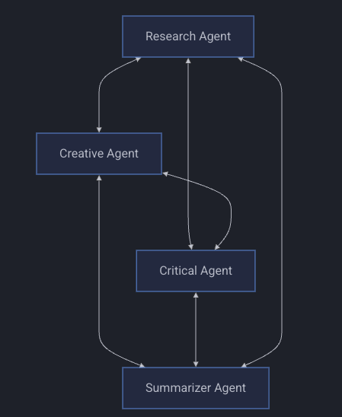
- 3. Workflow: An agent workflow is a structured coordination of tasks across multiple AI agents, where each agent performs specialized functions in a defined sequence or pattern. By breaking down complex problems into manageable components and distributing them to specialized agents, workflows provide explicit control over task execution order, dependencies, and information flow, ensuring reliable outcomes for processes that require specific execution patterns.
Strands Agents SDK allows you to create workflows using existing Agent objects, even when they use different model providers or have different configurations. It also provides a built-in workflow tool that simplifies multi-agent workflow implementation by handling task creation, dependency resolution, parallel execution, and information flow automatically.
Use workflow orchestration in-built tool for managing parallel AI tasks with background execution. It also supports task dependencies, concurrent execution, and real-time status tracking.
Below is a Sequential workflow example -
Research Agent
Analysis Agent
Report Agent
- 4. Agent Graph: Agent graphs provide a structured approach to building multi-agent systems with precise control over information flow and agent interactions. By organizing agents into topologies developers can create sophisticated systems tailored to specific tasks. The Strands Agents SDK supports both custom implementations through tool-based communication and simplified creation via the agent_graph tool.
Key Features of agent_graph in built tool:
- Multiple topology support (star, mesh, hierarchical)
- Dynamic message routing
- Parallel agent execution
- Real-time status monitoring
- Flexible agent configuration
Below is a Mesh topology graph example -
Mesh Topology
Agent 2
Agent 1
Agent 3
Agent 4

When to Use Each Tool

Pattern | When to Use | Use Case Examples | Strands Tool Implementation
Workflow | - Tasks with distinct sequential stages - Processes requiring different capabilities at each stage - Dependency-Heavy Tasks - Running independent tasks in parallel while managing dependencies - Retrying specific failed steps without restarting the entire process - Tasks requiring monitoring, pausing, or resuming capabilities - When detailed tracking of each step is necessary | - Data Pipeline Processing - ETL operations - Multi-stage document processing - Sequential decision workflows | - Tasks define dependencies, priorities, timeouts - Thread pool scaling (2-8 threads) - Supports Persistent state storage (~/.strands/workflows) - Priority levels 1-5 for scheduling
Swarm | - Parallel execution of multiple AI instances - Shared memory system for collective intelligence - Collaborative, competitive, or hybrid agent interaction is desired - Phase-based progression for complex reasoning | - Brainstorming or Problem Solving - Research Analysis with Multiple Perspectives - Collective decision making - Parallel problem exploration | - Configurable coordination patterns - Constants for resource management are MAX_THREADS = 10 - Each agent approaches the same task differently
Agent Graph | - Custom topologies and interaction patterns - Long-running agent networks that maintain context - Different agents with distinct capabilities - Fine-grained control of information flow is required | - Complex System Simulation - Hierarchical Decision-Making - Networked information processing - Role-based collaborative systems | - Custom topologies: star, mesh, hierarchical - Each node has unique ID, role, and system prompt - Message passing between connected nodes - Real-time status monitoring

Conclusion

Each tool has its strengths and optimal use cases. You can explore creating custom multi-agent agent architectures, or leverage the Strands agents tool to get started. The best results often come from combining patterns - for example, using Workflow to orchestrate a process that includes Swarm for brainstorming and Agent Graph for communication patterns. For complex tasks, Strands can orchestrate across multiple agents in a variety of multi-agent collaboration patterns. By modeling sub-agents and multi-agent collaboration as tools, the model-driven approach enables the model to reason about if and when a task requires a defined workflow, graph, or swarm of sub-agents. Explore different combinations for your specific use case.

Lab 9a - Multi agent system with Agent as a tool.

Overview

In this section, you'll learn how to use a Strands Agent as a tool .
This example demonstrates how to create a multi-agent collaboration system by using one agent as a tool for another agent. This approach allows for specialized AI agents to combine their strengths and work together to solve complex problems.
You will see how it mimics human team dynamics, where a manager coordinates specialists, each bringing unique expertise to solve complex problems. Rather than a single agent trying to handle everything, tasks are delegated to the most appropriate specialized agent.
Delegates tasks
Delegates tasks
Delegates tasks
Returns results
Returns results
Returns results
Interacts with
Orchestrator Agent
Research Assistant
Product Recommendation Assistant
Trip Planning Assistant
User

What You'll Build

- The example creates specialized agents with specific expertise areas (Trip Planning, Product recommendation, Research Assistant )
- These specialized agents are wrapped as tools that can be invoked by a primary orchestrator agent
- The primary agent decides when to use these specialized agent tools based on the task requirements
- The primary agent combines and coordinates all responses to provide the final output
- Explore sequentail communication pattern betwee Agents.

Architecture

Agents as Tools is an architectural pattern in AI systems where specialized AI agents are wrapped as callable functions (tools) that can be used by other agents. This creates a hierarchical structure where:
A primary "orchestrator" agent handles user interaction and determines which specialized agent to call
Specialized "tool agents" perform domain-specific tasks when called by the orchestrator
In this module we will be creating an orchestrator based multi-agent.
- Agent tools created: research_assistant, product_recommendation_assistant, trip_planning_assistant
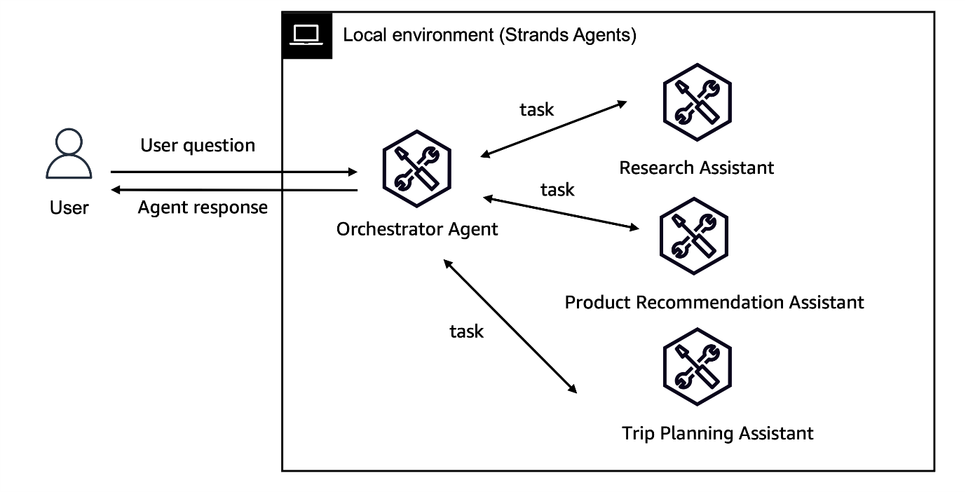

Prerequisites

Before starting this workshop, ensure you have:
- Python 3.10 or higher installed
- An AWS account
- Anthropic Claude Sonnet 4.5 enabled on Amazon Bedrock (guide )
- IAM role with permissions to use Amazon Bedrock
- Packages required: strands-agents, strands-agents-tools

Step 1: Create your Specilaised Agents and use it as tool

Best Practices for Agent as Tools When implementing the "Agents as Tools" pattern :
- Clear tool documentation: Write descriptive docstrings that explain the agent's expertise
- Focused system prompts: Keep each specialized agent tightly focused on its domain
- Proper response handling: Use consistent patterns to extract and format responses
- Tool selection guidance: Give the orchestrator clear criteria for when to use each specialized agents.
Create a Research Agent as defined in the notebook:
1
2
3
4
5
6
7
8
research_agent = Agent(
system_prompt=RESEARCH_ASSISTANT_PROMPT,
# tools=[http_request] # Here you can enable an agentic ai search tool
)

query = "Overview of Amazon Bedrock and its features"
# Call the agent and return its response
response = research_agent(query)
Now, You can wrap this reasearch_agent as a tool using the @tool decorator. This allows you to transform specialized agents into callable functions that can be used by an orchestrator agent.
1
2
3
4
5
6
7
8
9
10
11
12
13
14
15
16
17
18
19
20
21
22
@tool
def research_assistant(query: str) -> str:
"""
Process and respond to research-related queries.

Args:
query: A research question requiring factual information

Returns:
A detailed research answer with citations
"""
try:
# Strands agents makes it easy to create a specialized agent
research_agent = Agent(
system_prompt=RESEARCH_ASSISTANT_PROMPT,
)

# Call the agent and return its response
response = research_agent(query)
return str(response)
except Exception as e:
return f"Error in research assistant: {str(e)}"
Following a similar approach, you will create two more specialized Agents as tools as defined in the notebook.
Product Recommendation Assistant: It is a specialized product recommendation assistant. Provide personalized product suggestions based on user preferences. Always cite your sources.
Trip Planning Assistant: It is a specialized travel planning assistant. Create detailed travel itineraries based on user preferences.

Step 2: Create the Orchestrator Agent

Define the Orchestrator Agent system prompt with clear tool selection guidance and add the agent tools deifned from the previous steps as tools.
1
2
3
4
5
6
7
8
9
10
11
12
13
14
15
16
17
18
19
20
MAIN_SYSTEM_PROMPT = """
You are an assistant that routes queries to specialized agents:
- For research questions and factual information → Use the research_assistant tool
- For product recommendations and shopping advice → Use the product_recommendation_assistant tool
- For travel planning and itineraries → Use the trip_planning_assistant tool
- For simple questions not requiring specialized knowledge → Answer directly

Always select the most appropriate tool based on the user's query.
"""

# Strands Agents allows easy integration of agent tools
orchestrator = Agent(
system_prompt=MAIN_SYSTEM_PROMPT,
tools=[
research_assistant,
product_recommendation_assistant,
trip_planning_assistant,
file_write,
],
)

Step 3: Test the Orchestrator Agent

Example 1: E-commerce Customer Service System

1
2
3
4
5
6
customer_query = (
"I'm looking for hiking boots. Write the final response to current directory."
)
os.environ["DEV"] = "true"
# The orchestrator automatically determines this requires multiple specialized agents
response = orchestrator(customer_query)
To dive into the details, inspect the history using .messages to see which agent tool was selected -
1
orchestrator.messages
Congratulations, You created a multi-agent orchestrator. The "Agents as Tools" pattern offers several advantages:
- Separation of concerns: Each agent has a focused area of responsibility, making the system easier to understand and maintain
- Hierarchical delegation: The orchestrator decides which specialist to invoke, creating a clear chain of command
- Modular architecture: Specialists can be added, removed, or modified independently without affecting the entire system
- Improved performance: Each agent can have tailored system prompts and tools optimized for its specific task
Test this agent with other queries:
For example - "Can you help me plan my trip to Patagonia"

Example 2 : Calling multiple Agents -

You can also test the agent with queries that will require multiple inputs from multiple specilised agents -
1
2
3
query = "Can you do a research on spain? Also help me plan a 7 day trip."

orchestrator(query)
Behind the scenes, the orchestrator will:
- First call the research_assistant
- Then call trip_planning_assistant
- Combine these specialized responses into a cohesive answer that addresses both the queries

Step 4: Exploring Sequential Agent Communication Pattern

The agent tool can also combine multiple agents together. In this example we will provide output of research_agent to summary_agent and return the summarized response.
Query
Research Results
Concise Summary
User
Research Agent
Summary Agent
1
2
3
4
5
6
7
8
9
10
11
12
13
14
15
16
17
18
19
20
21
22
23
24
25
26
27
28
29
30
31
32
33
34
35
36
37
38
39
40
41
42
43
44
45
# Facilitate communication between agents

@tool
def research_assistant_2(topic: str):
"""
Process and respond to research-related queries.

Args:
topic: A research topic requiring factual information

Returns:
A detailed research answer with citations
"""
research_agent = Agent(
system_prompt=RESEARCH_ASSISTANT_PROMPT,
)

# Create a summarization agent
summary_agent = Agent(
system_prompt="""
You are a summarization specialist focused on distilling complex information into clear, concise summaries.
Your primary goal is to take detailed information and extract the key points, main arguments, and critical data.
You should maintain the accuracy of the original content while making it more digestible.
Focus on clarity, brevity, and highlighting the most important aspects of the information.
""",
)

print("Multiple agents created successfully!")
print(f"\n🔍 RESEARCH AGENT working on: {topic}\n")
# Ask the research agent to gather information
try:
research_response = research_agent(
f"Please gather comprehensive information about {topic}."
)
research_text = research_response.message.content[0]["text"]

print("\n✂️ SUMMARY AGENT distilling the research\n")
# Ask the summary agent to create a concise summary
summary_response = summary_agent(
f"Please create a concise summary of this research: {research_text}"
)
summary_text = summary_response.message.content[0]["text"]
return str(summary_text)
except Exception as e:
return f"Error in research assistant: {str(e)}"

Try it out

At an AWS Event

If you are following the workshop via workshop studio, now go to JupyterLab in SageMaker Studio. In the JupyterLab UI navigate to 01-tutorials/02-multi-agent-systems/01-agent-as-tool/agent-as-tools.ipynb

Self-paced

Here's a notebook that lets you try out the above: Create Orchestrator Multi Agent with Agent as tools .

Conclusion

Congrats ! You have learnt how Strands Agents SDK enables specialized experts to collaborate on complex queries requiring multiple domains of knowledge. The orchestrator intelligently routes different aspects of the query to the appropriate specialized agents, then synthesizes their responses into a comprehensive answer. By following the best practices outlined earlier and leveraging Strands Agents SDK's capabilities, you can build sophisticated multi-agent systems that handle complex tasks through specialized expertise.

Lab 9b - Multi-Agent Systems with Swarm Intelligence

Overview

In this section, you'll learn how to create a multi agent system with swarm intelligence .
What is a Agent Swarm ? An agent swarm is a collection of autonomous AI agents working together to solve complex problems through collaboration. Inspired by natural systems like ant colonies or bird flocks, agent swarms leverage collective intelligence where the combined output exceeds what any single agent could produce. By distributing tasks and sharing information, swarms can tackle complex problems more efficiently and effectively than individual agents working in isolation.

Key Features of Strands Swarms

- Self-organizing agent teams with shared working memory
- Tool-based coordination between agents
- Autonomous agent collaboration without central control
- Dynamic task distribution based on agent capabilities
- Collective intelligence through shared context
- Multi-modal input support for handling text, images, and other content types
Swarm intelligence emphasizes
- 창발적(emergent) 지능: 전문 에이전트 그룹은 단일 에이전트보다 문제를 더 효과적으로 해결합니다
- 공유 컨텍스트: 모든 에이전트는 전체 작업 컨텍스트와 이력을 액세스할 수 있습니다
- 자율적 조정: 에이전트는 전문성에 따라 작업 인계 시점을 결정합니다
- 안전 메커니즘: 무한 루프와 타임아웃에 대한 내장형 보호 기능이 있습니다

What You'll Build

A Strands Agent with the built-in swarm tool that simplifies the implementation of multi-agent systems, offering a quick start for users. You'll also learn to create native Swarms with autonomous coordination and shared context.

Prerequisites

Before starting this workshop, ensure you have:
- Python 3.10 or higher installed
- An AWS account
- Anthropic Claude Sonnet 4.5 enabled on Amazon Bedrock (guide )
- IAM role with permissions to use Amazon Bedrock

Step 1: Create a Multi-Agent System with the Swarm Tool

The Swarm tool in Strands SDK implements a swarm intelligence system that enables multiple Strands agents to collaborate on complex tasks through parallel processing and emergent collective intelligence.
How the Swarm Tool Works
- Task Analysis: Analyzes the input task to determine required agent specializations
- Agent Creation: Creates specialized agents based on specifications with individual configurations
- Swarm Initialization: Sets up the native Swarm with coordination tools and safety mechanisms
- Autonomous Execution: Agents collaborate through handoffs and shared context without central control
- Result Synthesis: Aggregates individual contributions and provides comprehensive execution metrics
For initializing an Agent with swarm tool, use the code shown below. This example shows how agents collaborate to design and implement a complete software solution:
1
2
3
4
5
from strands import Agent
from strands_tools import swarm

agent = Agent(tools=[swarm], system_prompt="Create a swarm of agents to solve the user's query.")
result = agent("Design and implement a REST API for a todo application with authentication")
Alternatively, you can use the swarm tool directly to create specialized agents:
1
2
3
4
5
6
7
8
9
10
11
12
13
14
15
16
17
18
19
20
21
22
23
24
25
26
27
28
29
30
31
from strands import Agent
from strands_tools import swarm

agent = Agent(tools=[swarm])
result = agent.tool.swarm(
task="Design and implement a REST API for a todo application with authentication",
agents=[
{
"name": "system_architect",
"system_prompt": "You are a system architect who designs API structure, database schemas, and overall system architecture."
},
{
"name": "backend_developer",
"system_prompt": "You specialize in implementing backend code, API endpoints, and database operations."
},
{
"name": "security_specialist",
"system_prompt": "You focus on authentication, authorization, security best practices, and vulnerability assessment."
},
{
"name": "code_reviewer",
"system_prompt": "You review code for quality, performance, maintainability, and adherence to best practices."
},
{
"name": "documentation_writer",
"system_prompt": "You create comprehensive documentation, API specifications, and usage examples."
}
],
max_handoffs=20,
execution_timeout=600.0
)
Key Parameters for the swarm tool:
- task: The main task to be processed by the swarm
- agents: List of agent specifications with name, system_prompt, tools, model_provider, and model_settings
- max_handoffs: Maximum number of agent handoffs allowed (default: 20)
- max_iterations: Maximum total iterations across all agents (default: 20)
- execution_timeout: Total execution timeout in seconds (default: 900.0)
- node_timeout: Individual agent timeout in seconds (default: 300.0)
- repetitive_handoff_detection_window: Number of recent nodes to check for ping-pong behavior (default: 0)
- repetitive_handoff_min_unique_agents: Minimum unique nodes required in recent sequence (default: 0)
You can print the result to see how the 5 specialized agents collaborate through autonomous handoffs, building upon each other's work to create a complete software solution.
1
2
3
4
5
6
print(f"Status: {result.status}")
print(f"Final result: {result.result}")

# See which agents were involved
for node in result.node_history:
print(f"Agent: {node.node_id}")

Step 2: Explore Swarm Configuration Parameters

Let's explore how different configuration parameters affect swarm behavior and performance:

Swarm Configuration Parameters

The Swarm constructor allows you to control behavior and safety parameters:
Parameter | Description | Default
max_handoffs | Maximum number of agent handoffs allowed | 20
max_iterations | Maximum total iterations across all agents | 20
execution_timeout | Total execution timeout in seconds | 900.0 (15 min)
node_timeout | Individual agent timeout in seconds | 300.0 (5 min)
repetitive_handoff_detection_window | Number of recent nodes to check for ping-pong behavior | 0 (disabled)
repetitive_handoff_min_unique_agents | Minimum unique nodes required in recent sequence | 0 (disabled)

Example: Configuring Safety Mechanisms

1
2
3
4
5
6
7
8
9
10
11
12
13
14
15
16
17
18
19
20
21
22
23
24
25
26
27
28
29
30
result = agent.tool.swarm(
task="Create a mobile app architecture for an e-commerce platform",
agents=[
{
"name": "mobile_architect",
"system_prompt": "You are a mobile architect. Design the overall mobile app architecture, focusing on scalability and performance."
},
{
"name": "ux_designer",
"system_prompt": "You are a UX designer. Create user flows and interface designs that prioritize usability and accessibility."
},
{
"name": "performance_engineer",
"system_prompt": "You are a performance engineer who identifies potential bottlenecks and optimization opportunities."
},
{
"name": "technical_lead",
"system_prompt": "You are the technical lead who evaluates proposals and makes final architectural decisions."
}
],
max_handoffs=15,
max_iterations=15,
execution_timeout=600.0,
node_timeout=180.0,
repetitive_handoff_detection_window=6,
repetitive_handoff_min_unique_agents=3
)

print(f"Status: {result.status}")
print(f"Final result: {result.result}")

How Swarms Work

Swarms operate on the principle of emergent intelligence - specialized agents working together solve problems more effectively than a single agent. Each agent in a Swarm:
- Has access to the full task context
- Can see the history of which agents have worked on the task
- Can access shared knowledge contributed by other agents
- Can decide when to hand off to another agent with different expertise
The swarm tool leverages the Strands SDK's native Swarm pattern with built-in coordination tools. Each agent is automatically equipped with handoff_to_agent and complete_swarm_task tools, enabling autonomous coordination through shared context and working memory. This enables emergent collective intelligence where agents decide when to collaborate or handoff based on their expertise and the task requirements.

Step 3: Creating a Swarm with Strands Agents

Strands Agents SDK allows you to create swarms using existing Agent objects with the native Swarm class. The Swarm enables autonomous coordination between agents through built-in handoff tools and shared context, allowing agents to dynamically transfer control when they need specialized expertise from other agents.

Architecture

The Strands SDK's native Swarm pattern uses autonomous agent coordination with built-in handoff tools. The following example demonstrates a swarm of specialized agents collaborating through shared context and autonomous handoffs:

You will create specialized agents with distinct capabilities like a Research Agent, Creative Agent, Critical Agent and a Summarizer Agent. These agents will use the Swarm's built-in coordination tools to autonomously handoff to each other when they need different expertise.
Below is how you create specialized agents and set up the Swarm:
1
2
3
4
5
6
7
8
9
10
11
12
13
14
15
16
17
18
19
20
21
22
23
24
25
26
27
28
29
30
31
32
33
34
35
36
37
38
39
40
41
42
43
44
45
46
47
48
49
50
51
52
53
54
55
56
57
58
59
60
61
62
63
64
65
66
import logging
from strands import Agent
from strands.multiagent import Swarm

# Enable debug logs to see swarm coordination
logging.getLogger("strands.multiagent").setLevel(logging.DEBUG)
logging.basicConfig(
format="%(levelname)s | %(name)s | %(message)s",
handlers=[logging.StreamHandler()]
)

# Create specialized agents with different expertise
research_agent = Agent(
name="research_agent",
system_prompt="""You are a Research Agent specializing in gathering and analyzing information.
Your role in the swarm is to provide factual information and research insights on the topic.
You should focus on providing accurate data and identifying key aspects of the problem.
When you need creative input or critical analysis, use handoff_to_agent to transfer to the appropriate specialist."""
)

creative_agent = Agent(
name="creative_agent",
system_prompt="""You are a Creative Agent specializing in generating innovative solutions.
Your role in the swarm is to think outside the box and propose creative approaches.
You should build upon information from other agents while adding your unique creative perspective.
When you need research data or critical evaluation, handoff to the appropriate agent."""
)

critical_agent = Agent(
name="critical_agent",
system_prompt="""You are a Critical Agent specializing in analyzing proposals and finding flaws.
Your role in the swarm is to evaluate solutions proposed by other agents and identify potential issues.
You should carefully examine proposed solutions, find weaknesses or opportunities for improvement.
When you need additional research or creative alternatives, handoff to the appropriate agent."""
)

summarizer_agent = Agent(
name="summarizer_agent",
system_prompt="""You are a Summarizer Agent specializing in synthesizing information from multiple sources.
Your role in the swarm is to take inputs from other agents and create comprehensive, well-structured summaries.
You should integrate insights from research, creative, and critical perspectives into a cohesive final result."""
)

# Create a swarm with these agents
swarm = Swarm(
[research_agent, creative_agent, critical_agent, summarizer_agent],
max_handoffs=20,
max_iterations=20,
execution_timeout=900.0, # 15 minutes
node_timeout=300.0, # 5 minutes per agent
repetitive_handoff_detection_window=8, # There must be >= 3 unique agents in the last 8 handoffs
repetitive_handoff_min_unique_agents=3
)

# Execute the swarm on a task
result = swarm("Design and implement a simple REST API for a todo app")

# Access the final result
print(f"Status: {result.status}")
print(f"Node history: {[node.node_id for node in result.node_history]}")
print(f"Final result: {result.result}")

# Get performance metrics
print(f"Total iterations: {result.execution_count}")
print(f"Execution time: {result.execution_time}ms")
print(f"Token usage: {result.accumulated_usage}")

Swarm Coordination Tools

When you create a Swarm, each agent is automatically equipped with special tools for coordination:

Handoff Tool

Agents can transfer control to another agent when they need specialized help:
1
2
3
4
5
handoff_to_agent(
agent_name="creative_agent",
message="I need help generating innovative solutions for this problem",
context={"research_findings": "..."}
)

Shared Context

The Swarm maintains a shared context that all agents can access. This includes:
- The original task description
- History of which agents have worked on the task
- Knowledge contributed by previous agents
- List of available agents for collaboration
The formatted context for each agent looks like:
Handoff Message: I need help generating innovative solutions for this problem

User Request: Design and implement a simple REST API for a todo app

Previous agents who worked on this: research_agent → creative_agent

Shared knowledge from previous agents:
• research_agent: {"api_requirements": "CRUD operations", "tech_stack": "Python Flask", "database": "SQLite"}
• creative_agent: {"innovative_features": "real-time updates", "user_experience": "intuitive design"}

Other agents available for collaboration:
Agent name: critical_agent. Agent description: Analyzes proposals and finds potential issues
Agent name: summarizer_agent. Agent description: Synthesizes information from multiple sources

You have access to swarm coordination tools if you need help from other agents.
In this example:
- The research_agent might start by analyzing requirements and handing off to the creative_agent
- The creative_agent generates innovative solutions and hands off to the critical_agent
- The critical_agent evaluates the proposals and identifies potential issues
- Finally, the summarizer_agent synthesizes all inputs into a comprehensive solution
Congratulations, you've implemented a swarm architecture with autonomous coordination using Strands Agents SDK!

Multi-Modal Input Support

Swarms support multi-modal inputs like text and images using ContentBlocks:
1
2
3
4
5
6
7
8
9
10
11
12
13
14
15
16
17
18
19
from strands import Agent
from strands.multiagent import Swarm
from strands.types.content import ContentBlock

# Create agents for image processing workflow
image_analyzer = Agent(name="image_analyzer", system_prompt="You are an image analysis expert...")
report_writer = Agent(name="report_writer", system_prompt="You are a report writing expert...")

# Create the swarm
swarm = Swarm([image_analyzer, report_writer])

# Create content blocks with text and image
content_blocks = [
ContentBlock(text="Analyze this image and create a report about what you see:"),
ContentBlock(image={"format": "png", "source": {"bytes": image_bytes}}),
]

# Execute the swarm with multi-modal input
result = swarm(content_blocks)

Asynchronous Execution

You can also execute a Swarm asynchronously:
1
2
3
4
5
6
7
import asyncio

async def run_swarm():
result = await swarm.invoke_async("Design and implement a complex system...")
return result

result = asyncio.run(run_swarm())
When to use Swarm:
- For quick, parallel processing of a single complex task
- When you need multiple perspectives on the same problem
- For tasks that benefit from collective intelligence
- When you need autonomous coordination between specialized agents

Safety Mechanisms

Swarms include several safety mechanisms to prevent infinite loops and ensure reliable execution:
- Maximum handoffs: Limits how many times control can be transferred between agents
- Maximum iterations: Caps the total number of execution iterations
- Execution timeout: Sets a maximum total runtime for the Swarm
- Node timeout: Limits how long any single agent can run
- Repetitive handoff detection: Prevents agents from endlessly passing control back and forth

Best Practices

- Create specialized agents: Define clear roles for each agent in your Swarm
- Use descriptive agent names: Names should reflect the agent's specialty
- Set appropriate timeouts: Adjust based on task complexity and expected runtime
- Enable repetitive handoff detection: Set appropriate values for repetitive_handoff_detection_window and repetitive_handoff_min_unique_agents to prevent ping-pong behavior
- Include diverse expertise: Ensure your Swarm has agents with complementary skills
- Provide agent descriptions: Add descriptions to your agents to help other agents understand their capabilities
- Leverage multi-modal inputs: Use ContentBlocks for rich inputs including images

Next Steps

The native Swarm pattern provides autonomous coordination with shared context and working memory. This approach offers several advantages over manual mesh communication:
- Automatic coordination: Built-in handoff tools eliminate manual message passing
- Shared working memory: All agents have access to the full task context and history
- Safety mechanisms: Built-in protections against infinite loops and timeouts
- Performance metrics: Detailed execution statistics and token usage tracking
- Multi-modal support: Native support for text, images, and other content types

Try it out

At an AWS Event

If you are following the workshop via workshop studio, now go to JupyterLab in SageMaker Studio. In the JupyterLab UI navigate to 01-tutorials/02-multi-agent-systems/02-swarm-agent/swarm.ipynb

Self-paced

Here's a notebook that lets you try out the above: Create a Multi-Agent with Swarm .

Conclusion

Multi-agent swarms solve complex problems through collective intelligence. The Strands Agents SDK supports both custom implementations and a built-in swarm tool with shared memory. By distributing tasks across specialized agents and enabling effective communication, swarms achieve better results than single agents working alone.
As you familiarise with the swarm intelligence, please check out the documentation for more details on Mesh communication pattern, Shared Memory implementation and more!

Lab 9c - Agent Graph

Building Multi-Agent Systems with Strands Agent Graph

Overview

Strands Agent Graph is a structured network of interconnected specialized AI agents that can communicate with each other to solve complex problems. Let's look at how to create and manage agent graphs using the Strands SDK.
Multi-agent systems consist of multiple autonomous agents collaborating to solve complex problems through task distribution, specialization, and parallel processing. By using Strands Agent Graph, you can create different network topologies, manage communication between agents, and monitor their interactions.

What you'll build:

- Understand the three core components of agent graphs (nodes, edges, conditions)
- Send targeted messages between specific agents
- Monitor and control multi-agent networks
- Design specialized agent systems for real-world scenarios

Core Concepts

What is an Agent Graph?

A Graph is a deterministic Directed Acyclic Graph (DAG) based agent orchestration system where agents or other multi-agent systems (like Swarm or nested Graphs) are nodes in a graph. Nodes are executed according to edge dependencies, with output from one node passed as input to connected nodes.
- Deterministic execution order based on DAG structure
- Output propagation along edges between nodes
- Clear dependency management between agents
- Supports nested patterns (Graph as a node in another Graph)
- Conditional edge traversal for dynamic workflows
- Multi-modal input support for handling text, images, and other content types

Common Topologies

- Sequential Pipeline: Nodes are organized in a sequential order when one executes the task and forwards the output to another
- Parallel Processing: Agents received the tasks form the top agent and process in parallel the task and forward the result to an end node
- Branching Logic: Tree structure with parent-child relationships, ideal for layered processing, project management with task delegation, and multi-level review processes.

Prerequisites

Before getting started, ensure you have Anthropic Claude Sonnet 4.5 enabled on Amazon Bedrock.

Creating Your First Agent Graph

Before you begin to create the agents please take a note of following best practices below:
- Clear Role Definition: Each agent should have a specific, well-defined role
- Appropriate System Prompts: Tailor prompts to the agent's expertise and position
- Proper Cleanup: Always stop networks when they're no longer needed
- Status Monitoring: Regularly check network status for debugging
- Strategic Communication: Use targeted messaging for specific agents
- Resource Management: Monitor active networks to avoid resource waste

Basic processing

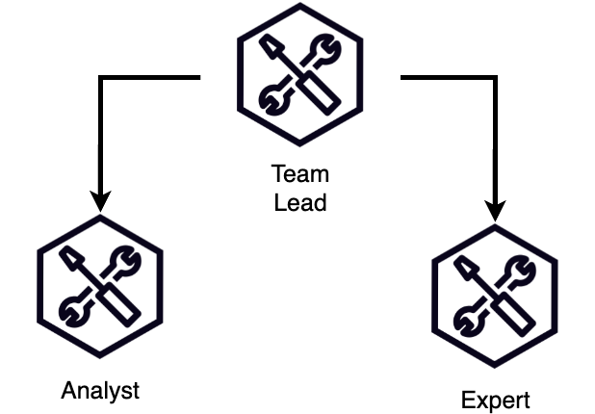
When to use:
- Content creation with editorial oversight
- Customer service with escalation paths
- Research coordination with specialists
To create this architecture with a team leader, you will use the GraphBUilder class form SDK and initialize the topology as shown below :
1
2
3
4
5
6
7
8
9
10
11
12
13
14
15
16
17
18
19
#Define Agents:
coordinator = Agent(name="coordinator", system_prompt="You are a research team leader coordinating specialists.Provide a short analysis, no need for follow ups")
analyst = Agent(name="data_analyst", system_prompt="You are a research team leader coordinating specialists.Provide a short analysis, no need for follow ups")
domain_expert = Agent(name="domain_expert", system_prompt="You are a research team leader coordinating specialists.Provide a short analysis, no need for follow ups")

# Add nodes
builder.add_node(coordinator, "team_lead")
builder.add_node(analyst, "analyst")
builder.add_node(domain_expert, "expert")

#Add connections
builder.add_edge("team_lead", "analyst")
builder.add_edge("team_lead", "expert")

#Build the graph
builder = GraphBuilder()

#Execute task on graph
result = graph("Analyze the impact of remote work on employee productivity.Provide a short analysis, no need for follow ups")

Strands Agents with parallel processing

Let's create a mesh topology where all agents can work on respective task in parallel and once completed final agent will formulate the outcome. You will create a decision committee agent with a financial advisor, technical architect, market researcher and risk analyst. The architecture looks as following:
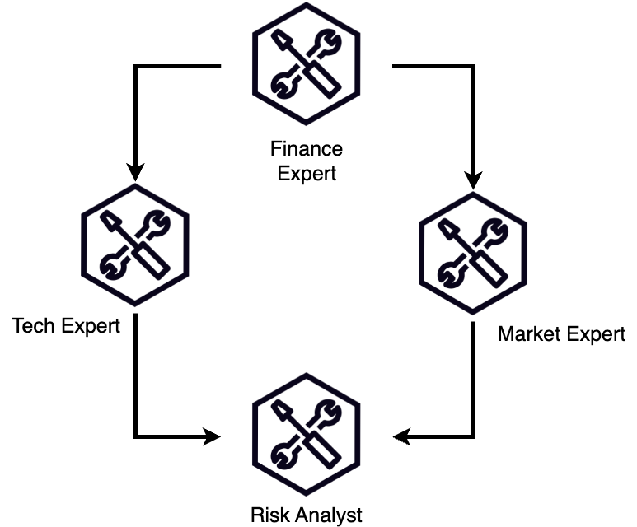
When to use Mesh topology:
- Collaborative problem-solving
- Consensus building and debates
- Peer review processes
You will initialize the parallel topology in similar fashion like in previous example - but the nodes will be connected differently:
1
2
3
4
5
6
7
8
9
10
11
12
13
14
15
16
17
18
19
20
21
22
23
24
25
26
27
28
# Create specialized agents
financial_advisor = Agent(name="financial_advisor", system_prompt="You are a financial advisor focused on cost-benefit analysis, budget implications, and ROI calculations. Engage with other experts to build comprehensive financial perspectives.")
technical_architect = Agent(name="technical_architect", system_prompt="You are a technical architect who evaluates feasibility, implementation challenges, and technical risks. Collaborate with other experts to ensure technical viability.")
market_researcher = Agent(name="market_researcher", system_prompt="You are a market researcher who analyzes market conditions, user needs, and competitive landscape. Work with other experts to validate market opportunities.")
risk_analyst = Agent(name="risk_analyst", system_prompt="You are a risk analyst who identifies potential risks, mitigation strategies, and compliance issues. Collaborate with other experts to ensure comprehensive risk assessment.")

# Build the graph
builder = GraphBuilder()

# Add nodes
builder.add_node(financial_advisor, "finance_expert")
builder.add_node(technical_architect, "tech_expert")
builder.add_node(market_researcher, "market_expert")
builder.add_node(risk_analyst, "risk_analyst")

# Add edges (dependencies)
builder.add_edge("finance_expert", "tech_expert")
builder.add_edge("finance_expert", "market_expert")
builder.add_edge("tech_expert", "risk_analyst")
builder.add_edge("market_expert", "risk_analyst")

# Set entry points (optional - will be auto-detected if not specified)
builder.set_entry_point("finance_expert")

# Build the graph
graph = builder.build()

Branching with conditions

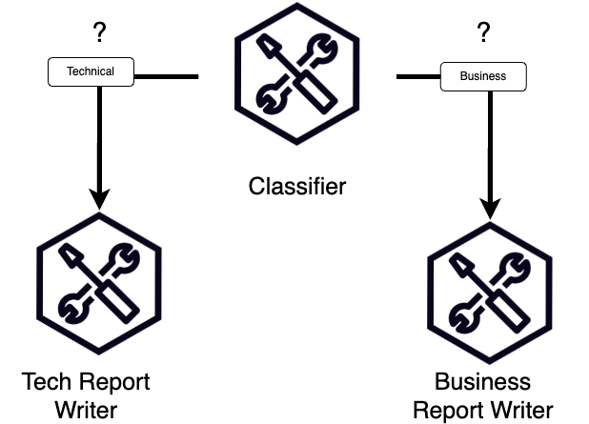
When to use branching with conditions
- Multi-level review processes
- Project management with delegation
- Layered data processing
- Categorization with conditions
Initialize the agent and connections similar to above examples, however notice the condition definition as well as their placement in the code and SDK syntax
1
2
3
4
5
6
7
8
9
10
11
12
13
14
15
16
17
18
19
20
21
22
23
24
25
26
27
28
29
30
31
32
33
34
35
36
37
38
39
40
from strands.multiagent import GraphBuilder

agent = Agent()
# Create specialized agents

classifier = Agent(name="classifier", system_prompt="You are an agent responsible for classification of the report request, return only Technical or Business classification.")
technical_report = Agent(name="technical_expert", system_prompt="You are a technical expert that focuses on providing short summary from technical perspective")
business_report = Agent(name="business_expert", system_prompt="You are a business expert that focuses on providing short summary from business perspective")

# Build the graph
builder = GraphBuilder()

# Add nodes
builder.add_node(classifier, "classifier")
builder.add_node(technical_report, "technical_report")
builder.add_node(business_report, "business_report")

def is_technical(state):
classifier_result = state.results.get("classifier")
if not classifier_result:
return False
result_text = str(classifier_result.result)
return "technical" in result_text.lower()

def is_business(state):
classifier_result = state.results.get("classifier")
if not classifier_result:
return False
result_text = str(classifier_result.result)
return "business" in result_text.lower()

# Add edges (dependencies)
builder.add_edge("classifier", "technical_report", condition=is_technical)
builder.add_edge("classifier", "business_report", condition=is_business)

# Set entry points (optional - will be auto-detected if not specified)
builder.set_entry_point("classifier")

# Build the graph
graph = builder.build()
Congratulations, you learnt how to create different types of Agent graph based multi-agent systems.

Key Features of agent graphs

- Dynamic Team Creation: Create specialized agent teams on-demand
- Task Distribution: Automatically distribute complex tasks across specialized agents
- Monitoring: Track the status and progress of your agent network

Use Cases

Agent graphs are particularly useful for:
- Research and analysis projects requiring multiple perspectives
- Content creation workflows with different specializations
- Problem-solving that benefits from diverse expertise
- Complex tasks that can be broken down into subtasks
- Scenarios requiring checks and balances between different agents

Try it out

At an AWS Event

If you are following the workshop via workshop studio, now go to JupyterLab in SageMaker Studio. In the JupyterLab UI navigate to 01-tutorials/02-multi-agent-systems/03-graph-agent/graph.ipynb

Self-paced

Here's a notebook that lets you try out the above: Create a Multi-Agent with Graph .

Conclusion

As you become more familiar with agent graphs, you can create increasingly sophisticated multi-agent systems tailored to your specific use cases. The key to successful multi-agent systems is:
- Defining clear agent roles and responsibilities
- Establishing proper communication patterns
- Managing resources and cleanup effectively

Deployment

Overview

So far we were building and running agents locally. But sooner or later you will want to build even more advanced solutions and deploy it's code to the cloud in order to make agent widely accessible. In this section we will cover two different options on how you can deploy the agent to the cloud and add additional validation to it's output:
- Lambda deployment
- Fargate deployment

Lab 10a - Deploying Strands Agents to AWS Lambda

Overview

AWS Lambda is a serverless compute service that lets you run code without provisioning or managing servers. This makes it an great choice for deploying Strands Agents because you only pay for the compute time you consume and don't need to manage hosts or servers.

What You'll Build

In this section you will build a restaurant booking assistant that will be capable of creating, updating and deleting booking appointments. Outside of Lambda function that will host the agent code we will also be using services such as DynamoDB, Amazon Bedrock and Bedrock Knowledge Bases

Architecture

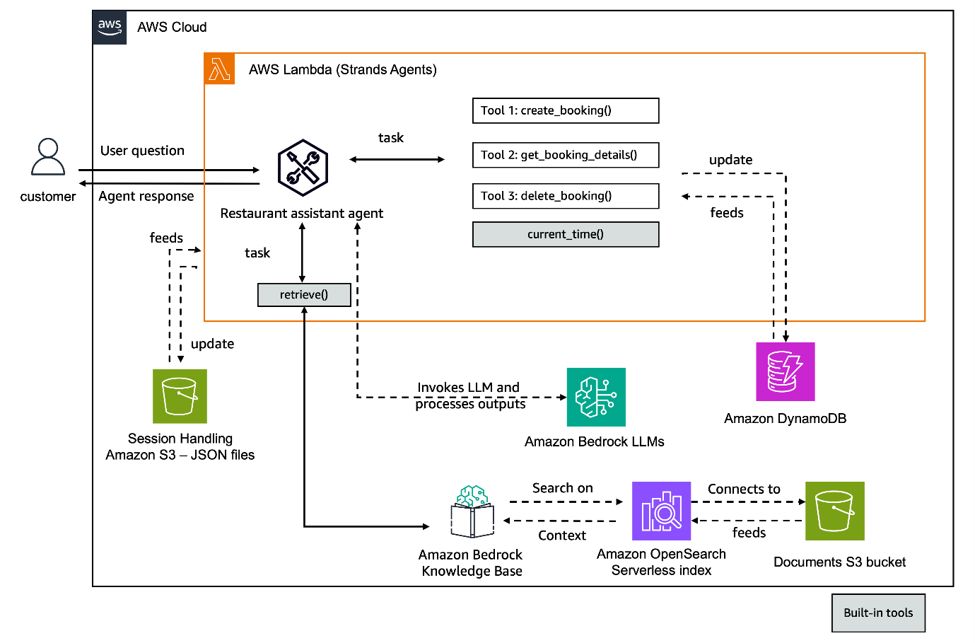

Prerequisites

- AWS CLI installed and configured
- Node.js (v18.x or later)
- Python 3.12 or later
- Either:
  - Podman installed and running
  - (or) Docker installed and running
  - Ensure podman or docker daemon is running.

CDK Setup

In order to start writing agent code we need to deploy the underlying infrastructure that will be used as tools by agent. In this section we will use AWS CDK to provision DynamoDB table and create Knowledge Base holding restaurant related data

Restaurant Agent setup

Now it's time to setup the agent. Those step involve creating multiple python files inside the /cdk/lambda directory. We will write files that hold code for tools and actual agent as well. After this section is completed you should hve 3 file in this folder:
1
2
3
4
5
6
7
8
#Retrieve booking from Dynamo DB
get_booking.py
#Delete booking in Dynamo DB
delete_booking.py
#Create booking in Dynamo DB~
create_booking.py
#Agent code:
app.py

Agent deployment

In your lab notebook you will find definition for AWS CDK StrandsLambdaStack This stack contains multiple infrastructure components that will deploy your agent to the cloud together with it's configuration and related tool definition that we just created in section above.

Invoke Agent

Once the stack is deployed you can directly test the agent functionality by invoking lambda function directly via boto3 SDK:
1
2
3
4
5
6
7
8
9
result = invoke_lambda(
function_name="StrandsAgent-agent-function",
payload={
"prompt": "Make a reservation for tonight at Rice & Spice.",
"session_id": session_id,
},
)

print(result)

Try it out

At an AWS Event

If you are following the workshop via workshop studio, now go to JupyterLab in SageMaker Studio. In the JupyterLab UI navigate to 01-tutorials/03-deployment/01-lambda-deployment/deploy-agent.ipynb

Self-paced

Here's a notebook that lets you try out the above: Deploying to AWS Lambda

Lab 10b - Deploying your agent to AWS Fargate

Overview

AWS Fargate is a serverless compute engine for containers that works with Amazon ECS and EKS. It allows you to run containers without having to manage servers or clusters. This makes it an excellent choice for deploying Strands AI agents as containerized applications with high availability and scalability.

Architecture

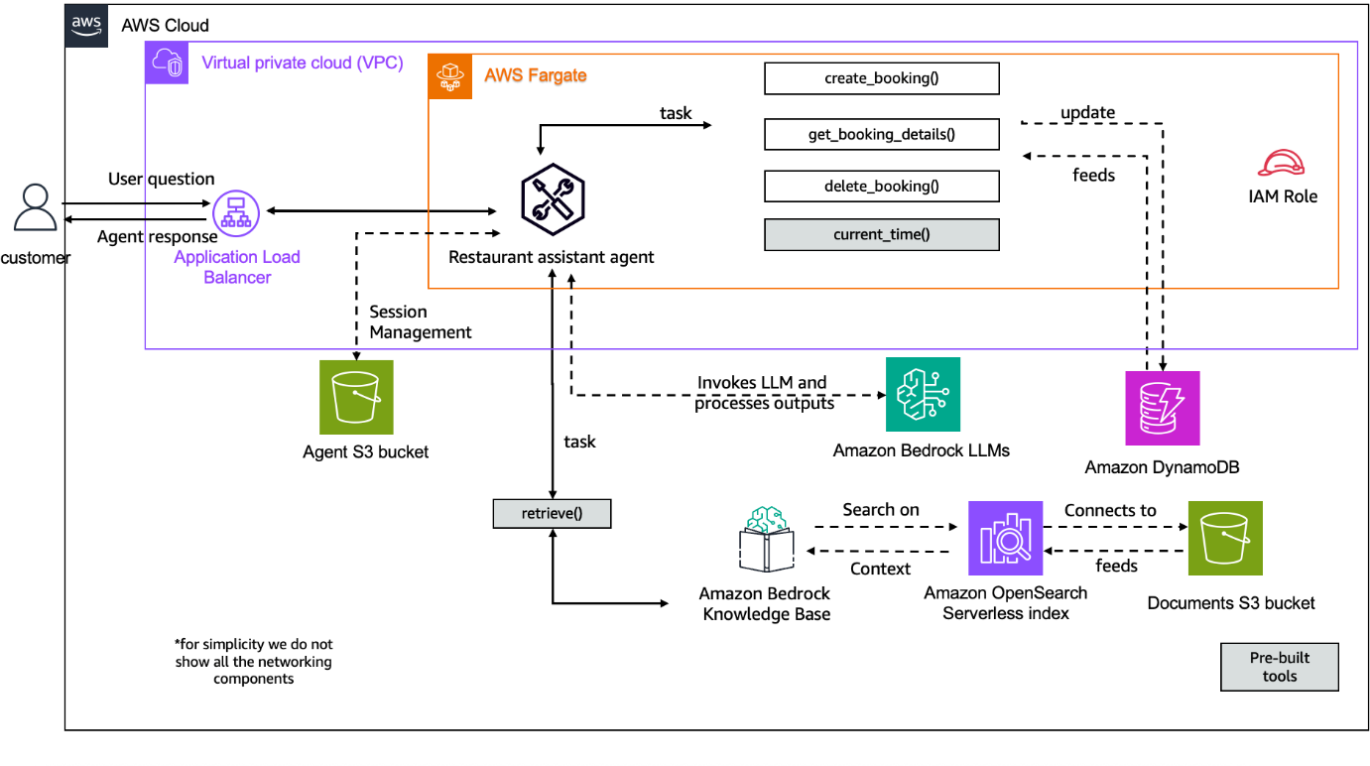
As you can see basic structure is similar to previous Lambda deployment, however we will be hosting the agent inside container managed by AWS Fargate service. From tthis contianer we will also expose two endpoints to provide responses back to the applications:
- /invoke - standard output
- /invoke-streaming - streaming output (real-time)

Prerequisites

- AWS CLI installed and configured
- Node.js (v18.x or later)
- Python 3.12 or later
- Either:
  - Podman installed and running
  - (or) Docker installed and running
  - Ensure podman or docker daemon is running.

Set Up

Similar to previous Lambda deployment we will use CDK to provision infrastructure elements needed for fully functioning agents.
sh deploy_prereqs.sh
We will also create multiple files the define tool and agent itself which we will hold in the docker/app/ folder
1
2
3
4
5
6
7
8
#Retrieve booking from Dynamo DB
get_booking.py
#Delete booking in Dynamo DB
delete_booking.py
#Create booking in Dynamo DB~
create_booking.py
#Agent code:
app.py

Deployment

Once we've created all necessary agent related files we can deploy the CDK stack to our account
!npx cdk deploy --require-approval never
This stack outside the files that we just created will also contain other elements like IAM Roles definitions, S3 bucket paths, VPC configuration for AWS Fargate service, container setup and Application Load Balancer configuration

Invoke agent

Once stack is deployed you need to get the URL of the newly deployed Fargate endpoint:
1
2
3
4
5
6
7
8
9
10
11
12
13
14
15
16
17
18
import subprocess
import requests

# Step 1: Get the service URL from CDK output using AWS CLI
result = subprocess.run(
[
"aws", "cloudformation", "describe-stacks",
"--stack-name", "StrandsAgentFargateStack",
"--query", "Stacks[0].Outputs[?ExportName=='StrandsAgent-service-endpoint'].OutputValue",
"--output", "text"
],
capture_output=True,
text=True
)

SERVICE_URL = result.stdout.strip()
print(f"Service URL: {SERVICE_URL}")
Now you can run test the agent operation:
1
2
3
4
5
6
7
8
response = requests.post(
f"http://{SERVICE_URL}/invoke/{session_id}",
headers={"Content-Type": "application/json"},
json={"prompt": "Hi, where can I eat in San Francisco?"}
)

# Print response
print("Response:", response.text)

Try it out

At an AWS Event

If you are following the workshop via workshop studio, now go to JupyterLab in SageMaker Studio. In the JupyterLab UI navigate to 01-tutorials/03-deployment/02-fargate-deployment/deploy-agent.ipynb

Self-paced

Here's a notebook that lets you try out the above: Deploying to AWS Fargate

Use Cases
After covering various aspects and integrations of Strands SDK in the previous section, in this section we will see how we can apply the approaches learnt in the previous section to real world applications.This covers two approaches.

Single Agent Systems

In this there is a single agent which uses a mix of custom and im-built tools to mimic a real world tasks.

Multi-Agent Systems

In this there is a hierarchial system with a primary orchestaror agents which based on the nature and context of query selects specialized agents, which have their own tooling. This provides greater flexibility and extra dimensionality for the system to mimic real world tasks.

Single Agent Systems

Restaurant Assistant

A restaurant assistant to streamline and enhance customer interactions. The AI assistant enables customers to seamlessly reserve tables at multiple partner restaurants, inquire about menus, create new bookings, retrieve details of existing reservations, or cancel bookings. This automation improves customer satisfaction, reduces staff workload, and increases booking efficiency, while providing restaurants with valuable insights into customer preferences and reservation trends.

Reference Architecture


This use case has the following configuration specs -
- Helper scripts to create knowledge base in AWS Bedrock and tables in AWS Dynamo DB
- In-built strand tools like current_time and retreive_time
- Custom tools viz. create_booking, get_booking_details, delete_booking
- Single Agent Architecture
This also details two approaches for defining tools-
- Decorator approach
When defining your tool using a decorator in a standalone file, your process is very similar to the one in the same file as your agent, but you will need to import or agent tool later on.
Decorator Approach example syntax
- TOOL_SPEC approach This approach uses a dictionary style data structure to define a tool.
Tool Spec Approach example syntax
The restaurant assistant agent gets a user query and then basically leverages Amazon Bedrock LLM's to decide what task it has to perform. The task boils down to the invocation of tools which are created using the decorator approach or Tool_Spec Approach. For this lab these are the tools which we are using.
- create_booking
This custom tool was created using the Tool_Spec Approach and is a object with propereties viz. date, hour, restaurant_name, guest_name,num_guests. This tool uses the restaurant information retrieved from the Bedrock knowledge base which is built on top of the indexes on Opensearch and the restaurant data is in S3 files. The tool then adds the remaining properties to create a booking and logs the details into the Dynamo DB database.
- delete_booking
This custom tool was created using the Decorator Approach and is a object with propereties viz. booking_id and restaurant name.The tool looks for the booking_id and restaurant_name in Dynamo DB table and deletes them based on the agent
- get_booking_details
This custom tool queries the Dynamo DB and return the booking details based on the details that are passed down from the agent.
- retrieve
The is an in-built strands tool which retrieves information from the Amazon Bedrock Knowledge base. The retrieve tool requires your Amazon Bedrock Knowledge Base id to be passed as parameter or to be available as environmental variable.
- current_time
The is an in-built strands tool to provide our agent with the information about the current time

Try it out

At an AWS Event

If you are following the workshop via workshop studio, now go to JupyterLab in SageMaker Studio. In the JupyterLab UI navigate to 02-samples/01-restaurant-assistant

Self-paced

Here's a notebook that lets you try out the above: restaurant-assistant .

Multi Agent Systems

Personal Assistant

A comprehensive productivity assistant that integrates calendar management, web search via Perplexity MCP Server, and development assistance through an intelligent multi-agent architecture.This uses agent as a tool functionality.

Reference Architecture

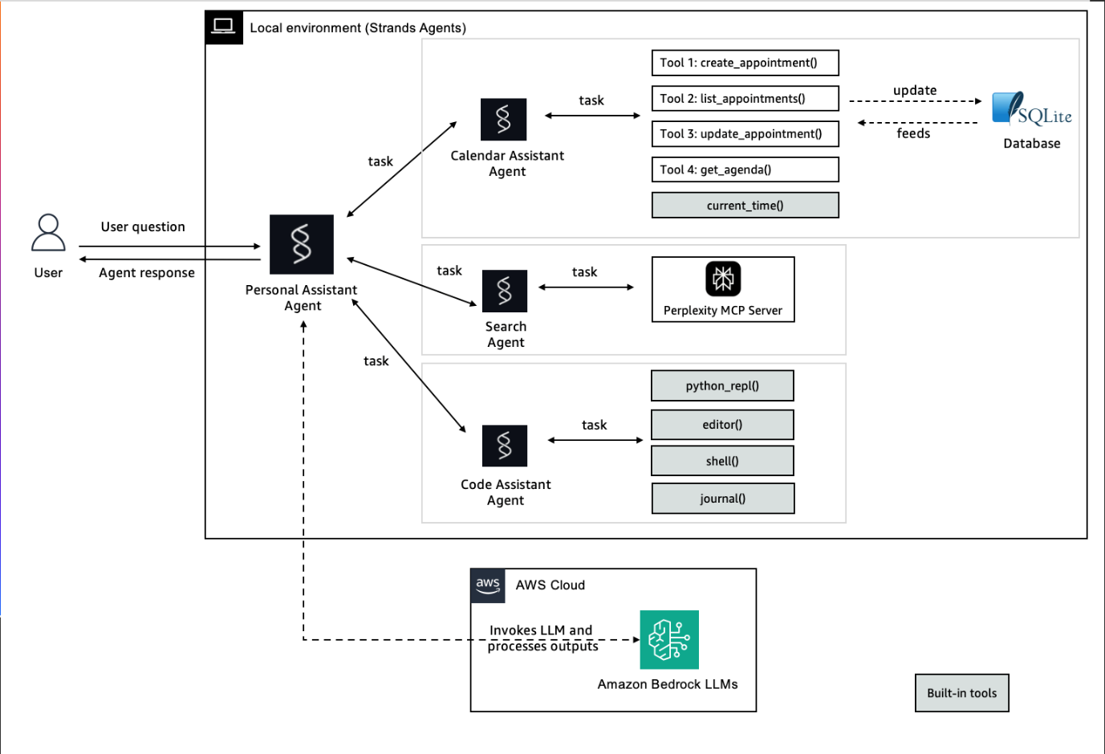
This use case has the following configuration specs -
- Python 3.10+
- Docker installed and running
- AWS Account with Bedrock access
- Strands Agents installed
- Required Python packages (see requirements.txt)
- Perplexity API key for MCP server
The architure has two important facets:
- Primary Orchestrator Agent - Personal Assistant Agent
- Specialized Agents - Calendar Assistant,Coding Assistant, Search Agent
The Primary Orchestrator Agent leverages AWS Bedrock LLM's to distribute tasks among the Specialized Agents viz. Calendar Assistant which uses inbuilt and custom tools, Coding Assitant which uses in-built strands tools python_repl, editor, shell, journal and Search Agent which leverage perplexity MCP server.
Specialized Agents' Tools
- Calendar Assistant
- Create Appointments: Schedule new appointments with date, time, location, and descriptions. This adds appointment to custom SQLite database.
- List All Appointments: View all scheduled appointments in a formatted list. This pulls data from custom SQLite database.
- Update Appointments: Modify existing appointments by ID. This performs a CRUD operation on custom SQLite database to custom SQLite database.
- Daily Agenda: Get a formatted agenda for any specific date, this queries custom SQLite database.
- Time Awareness : Built-in current time functionality. This is in-built strands tool.
Apart from Time Awareness the others are custom tools created in Strands to give Calendar Assistant agent the required capabilities.
- Coding Assistant
- Python REPL: Execute Python code in a REPL environment with PTY support and state persistence.
- Editor: Editor tool designed to do changes iteratively on multiple files.
- Shell Access: Interactive shell tool with PTY support for real-time command execution and interaction.
- Journal: Daily journal management tool for Strands Agent.
These are in-built strands tools for the coding assistant agent and the base LLM model uses Amazon Bedrock.
- Search Agent
- Web Search: Powered by Perplexity MCP Server for real-time information
This tool leverages the MCPClient library to establish connection and communication with the Perplexity MCP server to give search agent the web search functionality.

Try it out

At an AWS Event

If you are following the workshop via workshop studio, now go to JupyterLab in SageMaker Studio. In the JupyterLab UI navigate to 02-samples/05-personal-assistant

Self-paced

Here's a notebook that lets you try out the above: personal-assistant .

Summary

Congratulations!! You have learned how to build agents using Strands

More resources:

- API Reference: https://strandsagents.com/latest/api-reference/agent/
- Examples: https://strandsagents.com/latest/examples/
- Something missing in Strands Agents ? Please contribute to the SDK
Happy building !

